|  |  |  |  |
| --- | --- | --- | --- |
| **Customer:** | NORBORD MISSISSIPPI LLC | **Location/Desc:** | GUNTOWN |
| **Address:** | 1194 HWY 145 | **Performed by:** | JR Going |
|  | GUNTOWN,MS 38849 | **Date:** | 11/20/2024 |
| **Job/Order#** | 154016 |  |  |

|  |  |  |  |
| --- | --- | --- | --- |
| **Reason for call:** | Delivered fan, bearings, pulley, and bearing housing. Job number 154016 | | |
| **Description of work:** |  | | |
| **Equipment and material used:** |  | | |
| **Recommended additional work:** |  | | |

|  |  |  |  |
| --- | --- | --- | --- |
| **Main Contact:** | Jamie Hodge | | |
| **Customer Signature:** |  | | |

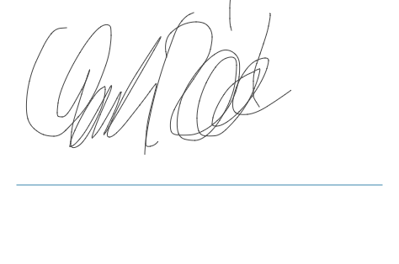

**NOTES**