|  |  |  |  |
| --- | --- | --- | --- |
| **Customer:** | Green Bay Packaging | **Location/Desc:** | Plummerville |
| **Address:** | Pinecrest Division | **Performed by:** | Lee Pettey |
|  | Plummerville,AR 72127 | **Date:** | 11/18/2024 |
| **Job/Order#** |  |  |  |

|  |  |  |  |
| --- | --- | --- | --- |
| **Motor Pickup:** | Picked up motor for eval **NOTES** | | |

|  |  |  |  |
| --- | --- | --- | --- |
| **Main Contact:** | Tyler Burgener | | |
| **Customer Signature:** |  | | |

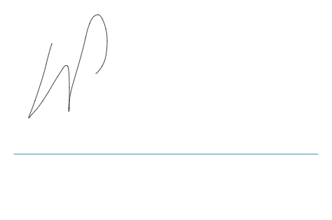

**NOTES**