|  |  |  |  |
| --- | --- | --- | --- |
| **Customer:** | Anchor Packaging | **Location/Desc:** | Paragould |
| **Address:** | 2211 N. 12th Ave. | **Performed by:** | JR Going |
|  | Paragould,AR 72450 | **Date:** | 11/05/2024 |
| **Job/Order#** |  |  |  |

|  |  |  |  |
| --- | --- | --- | --- |
| **Motor Pickup:** | Picked up 2 motors and gearbox. **NOTES** | | |

|  |  |  |  |
| --- | --- | --- | --- |
| **Main Contact:** | Lael Breckenridge | | |
| **Customer Signature:** |  | | |

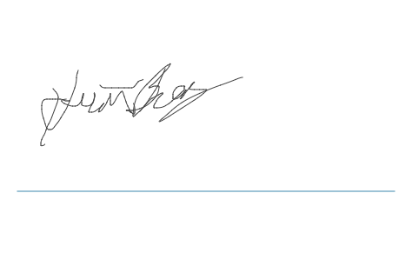

**NOTES**