|  |  |  |  |
| --- | --- | --- | --- |
| **Customer:** | MONDI BAGS | **Location/Desc:** | PINE BLUFF |
| **Address:** | 3501 JEFFERSON PARKWAY | **Performed by:** | Lee Pettey |
|  | PINE BLUFF,AR 71602 | **Date:** | 10/29/2024 |
| **Job/Order#** | 102687 |  |  |

|  |  |  |  |
| --- | --- | --- | --- |
| **Reason for call:** | delivered 44.5kw dc motor | | |
| **Description of work:** |  | | |
| **Equipment and material used:** |  | | |
| **Recommended additional work:** |  | | |

|  |  |  |  |
| --- | --- | --- | --- |
| **Main Contact:** | Gerald Lewis | | |
| **Customer Signature:** |  | | |

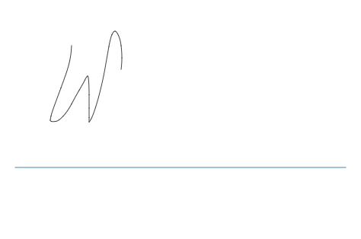

**NOTES**