|  |  |  |  |
| --- | --- | --- | --- |
| **Customer:** | Southern Cotton Oil | **Location/Desc:** | Memphis |
| **Address:** | 2782 Chelsea | **Performed by:** | JR Going |
|  | Memphis,TN 38108 | **Date:** | 10/24/2024 |
| **Job/Order#** | 153708 |  |  |

|  |  |  |  |
| --- | --- | --- | --- |
| **Reason for call:** | Delivered 250 HP motor. | | |
| **Description of work:** |  | | |
| **Equipment and material used:** |  | | |
| **Recommended additional work:** |  | | |

|  |  |  |  |
| --- | --- | --- | --- |
| **Main Contact:** | Randy Reigelsperger | | |
| **Customer Signature:** |  | | |

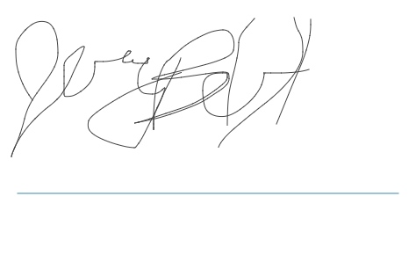

**NOTES**