|  |  |  |  |
| --- | --- | --- | --- |
| **Customer:** | PLASKOLITE INC | **Location/Desc:** | MILLINGTON |
| **Address:** | 2820 FITE RD | **Performed by:** | JR Going |
|  | MILLINGTON,TN 38053 | **Date:** | 10/23/2024 |
| **Job/Order#** |  |  |  |

|  |  |  |  |
| --- | --- | --- | --- |
| **Motor Pickup:** | Picked up gearbox. Said motors running at 90% with no load. **NOTES** | | |

|  |  |  |  |
| --- | --- | --- | --- |
| **Main Contact:** | Burt Barton | | |
| **Customer Signature:** |  | | |

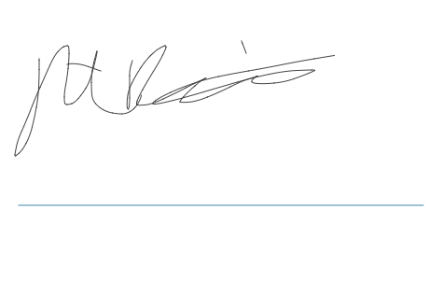

**NOTES**