|  |  |  |  |
| --- | --- | --- | --- |
| **Customer:** | U.S. Zinc | **Location/Desc:** | Millington |
| **Address:** | 3380 Fite Road | **Performed by:** | JR Going |
|  | Millington,TN 38053 | **Date:** | 10/23/2024 |
| **Job/Order#** | 153821 |  |  |

|  |  |  |  |
| --- | --- | --- | --- |
| **Reason for call:** | delivered 2.5 HP. Motor. | | |
| **Description of work:** |  | | |
| **Equipment and material used:** |  | | |
| **Recommended additional work:** |  | | |

|  |  |  |  |
| --- | --- | --- | --- |
| **Main Contact:** | Sean Stanford | | |
| **Customer Signature:** |  | | |

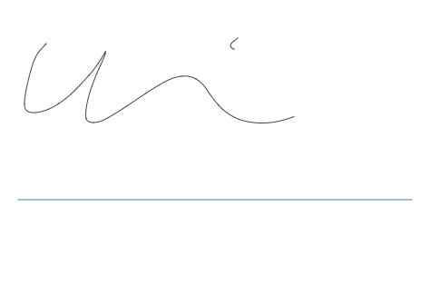

**NOTES**