|  |  |  |  |
| --- | --- | --- | --- |
| **Customer:** | Baxter Healthcare Corp | **Location/Desc:** | Cleveland |
| **Address:** | I. V. System Division | **Performed by:** | JR Going |
|  | Cleveland,MS 38732 | **Date:** | 10/19/2024 |
| **Job/Order#** |  |  |  |

|  |  |  |  |
| --- | --- | --- | --- |
| **Motor Pickup:** | Picked up 600 HP motor and 75 HP motor. **NOTES** | | |

|  |  |  |  |
| --- | --- | --- | --- |
| **Main Contact:** | Monty Barbatti | | |
| **Customer Signature:** |  | | |

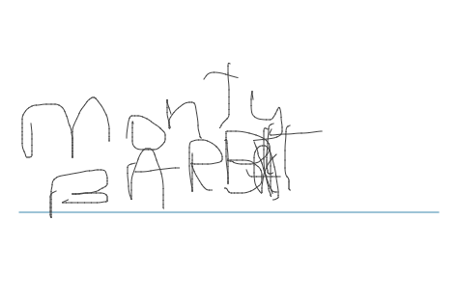

**NOTES**