|  |  |  |  |
| --- | --- | --- | --- |
| **Customer:** | THE GOODYEAR TIRE & RUBBER CO. | **Location/Desc:** | TUPELO |
| **Address:** | TUPELO - FACTORY | **Performed by:** | JR Going |
|  | TUPELO,MS 388046504 | **Date:** | 10/17/2024 |
| **Job/Order#** |  |  |  |

|  |  |  |  |
| --- | --- | --- | --- |
| **Reason for call:** | Delivered hoist. | | |
| **Description of work:** |  | | |
| **Equipment and material used:** |  | | |
| **Recommended additional work:** |  | | |

|  |  |  |  |
| --- | --- | --- | --- |
| **Main Contact:** | Dena Makamson | | |
| **Customer Signature:** |  | | |

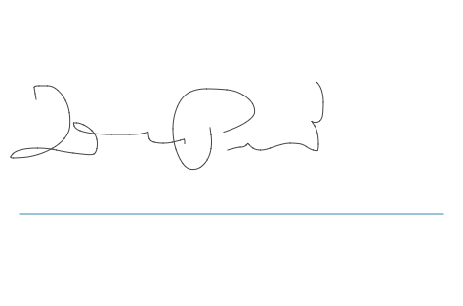

**NOTES**