|  |  |  |  |
| --- | --- | --- | --- |
| **Customer:** | ATS | **Location/Desc:** | PONTOTOC |
| **Address:** | C O MW COMPONENTS | **Performed by:** | JR Going |
|  | PONTOTOC,MS 38863 | **Date:** | 10/17/2024 |
| **Job/Order#** |  |  |  |

|  |  |  |  |
| --- | --- | --- | --- |
| **Motor Pickup:** | Picked up 60 hp motor. **NOTES** | | |

|  |  |  |  |
| --- | --- | --- | --- |
| **Main Contact:** | Stanton Sparks | | |
| **Customer Signature:** |  | | |

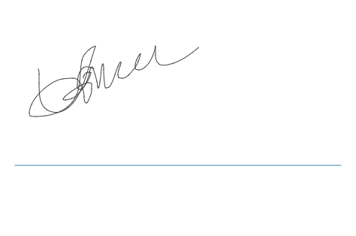

**NOTES**