|  |  |  |  |
| --- | --- | --- | --- |
| **Customer:** | Kimberly-Clark Corp | **Location/Desc:** | Corinth |
| **Address:** | Professional Mill | **Performed by:** | JR Going |
|  | Corinth,MS 38834 | **Date:** | 10/17/2024 |
| **Job/Order#** | 153651 |  |  |

|  |  |  |  |
| --- | --- | --- | --- |
| **Reason for call:** | delivered 200 HP motor PO C000084435 | | |
| **Description of work:** |  | | |
| **Equipment and material used:** |  | | |
| **Recommended additional work:** |  | | |

|  |  |  |  |
| --- | --- | --- | --- |
| **Main Contact:** | Even Harris | | |
| **Customer Signature:** |  | | |

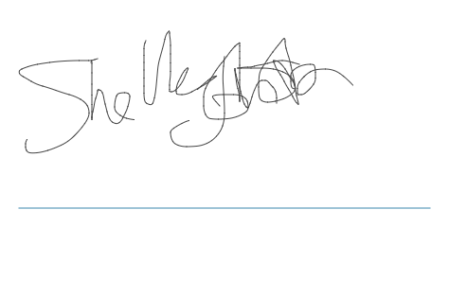

**NOTES**