|  |  |  |  |
| --- | --- | --- | --- |
| **Customer:** | Hershey | **Location/Desc:** | Memphis |
| **Address:** | 975 Kansas St. | **Performed by:** | JR Going |
|  | Memphis,TN 38106 | **Date:** | 10/10/2024 |
| **Job/Order#** | 153022 |  |  |

|  |  |  |  |
| --- | --- | --- | --- |
| **Reason for call:** | Delivered gearbox | | |
| **Description of work:** |  | | |
| **Equipment and material used:** |  | | |
| **Recommended additional work:** |  | | |

|  |  |  |  |
| --- | --- | --- | --- |
| **Main Contact:** | Larry Sullivan | | |
| **Customer Signature:** |  | | |

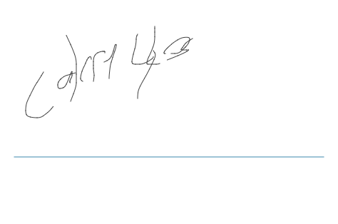

**NOTES**