|  |  |  |  |
| --- | --- | --- | --- |
| **Customer:** | POST FOODS, LLC | **Location/Desc:** | Jonesboro |
| **Address:** | 5800 C.W. Post Road | **Performed by:** | JR Going |
|  | Jonesboro,AR 72401 | **Date:** | 10/08/2024 |
| **Job/Order#** | 153617 |  |  |

|  |  |  |  |
| --- | --- | --- | --- |
| **Reason for call:** | delivered 75 HP motor. | | |
| **Description of work:** |  | | |
| **Equipment and material used:** |  | | |
| **Recommended additional work:** |  | | |

|  |  |  |  |
| --- | --- | --- | --- |
| **Main Contact:** | Rodney Manley | | |
| **Customer Signature:** |  | | |

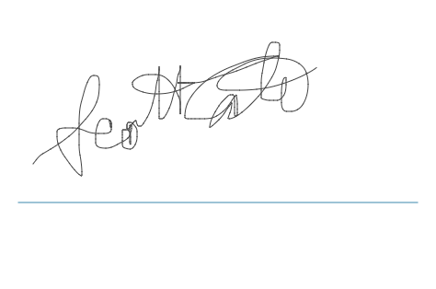

**NOTES**