|  |  |  |  |
| --- | --- | --- | --- |
| **Customer:** | Carlisle SynTec Inc. | **Location/Desc:** | Senatobia |
| **Address:** | 1201 Scott Street | **Performed by:** | JR Going |
|  | Senatobia,MS 38668 | **Date:** | 10/04/2024 |
| **Job/Order#** | 153774 |  |  |

|  |  |  |  |
| --- | --- | --- | --- |
| **Reason for call:** | delivered 50 HP motor. | | |
| **Description of work:** |  | | |
| **Equipment and material used:** |  | | |
| **Recommended additional work:** |  | | |

|  |  |  |  |
| --- | --- | --- | --- |
| **Main Contact:** | Tyler Brown | | |
| **Customer Signature:** |  | | |

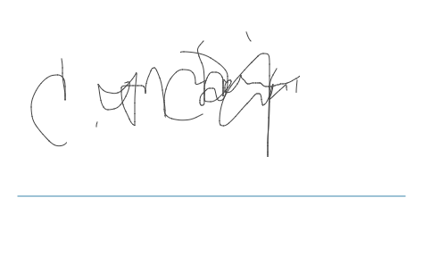

**NOTES**