|  |  |  |  |
| --- | --- | --- | --- |
| **Customer:** | Hershey | **Location/Desc:** | Memphis |
| **Address:** | 975 Kansas St. | **Performed by:** | JR Going |
|  | Memphis,TN 38106 | **Date:** | 10/02/2024 |
| **Job/Order#** |  |  |  |

|  |  |  |  |
| --- | --- | --- | --- |
| **Motor Pickup:** | Picked up 75HP motor and gearbox **NOTES** | | |

|  |  |  |  |
| --- | --- | --- | --- |
| **Main Contact:** | Larry Lyles | | |
| **Customer Signature:** |  | | |

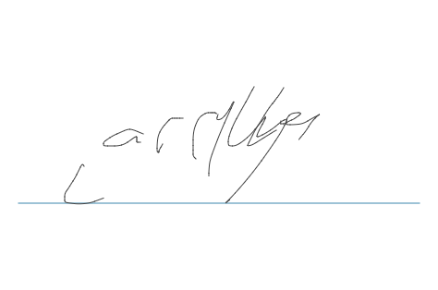

**NOTES**