|  |  |  |  |
| --- | --- | --- | --- |
| **Customer:** | Olin Corporation Centerfire | **Location/Desc:** | Oxford |
| **Address:** | Winchester Ammunition | **Performed by:** | JR Going |
|  | Oxford,MS 38655 | **Date:** | 10/01/2024 |
| **Job/Order#** |  |  |  |

|  |  |  |  |
| --- | --- | --- | --- |
| **Motor Pickup:** | Picked up 800 HP motor. **NOTES** | | |

|  |  |  |  |
| --- | --- | --- | --- |
| **Main Contact:** | Eric Rowsey | | |
| **Customer Signature:** |  | | |

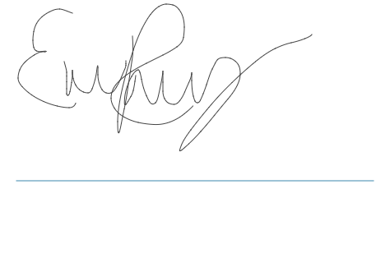

**NOTES**