|  |  |  |  |
| --- | --- | --- | --- |
| **Customer:** | W1A8 DLA Distribution | **Location/Desc:** | New Cumberland |
| **Address:** | DDSP New Cumberland Faci | **Performed by:** | JR Going |
|  | New Cumberland,PA 17070-500 | **Date:** | 09/30/2024 |
| **Job/Order#** |  |  |  |

|  |  |  |  |
| --- | --- | --- | --- |
| **Motor Pickup:** | Picked up inside sales order. 108729 to bring back to shop for shipping. **NOTES** | | |

|  |  |  |  |
| --- | --- | --- | --- |
| **Main Contact:** |  | | |
| **Customer Signature:** |  | | |

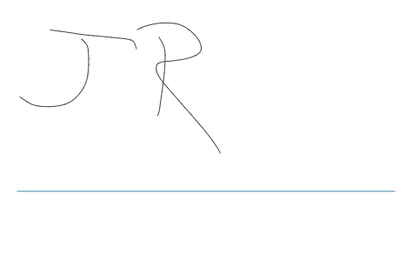

**NOTES**