|  |  |  |  |
| --- | --- | --- | --- |
| **Customer:** | GREENBRIER-MARMADUKE | **Location/Desc:** | MARMADUKE |
| **Address:** | 7755 HIGHWAY 34 E | **Performed by:** | JR Going |
|  | MARMADUKE,AR 72443-950 | **Date:** | 09/26/2024 |
| **Job/Order#** |  |  |  |

|  |  |  |  |
| --- | --- | --- | --- |
| **Motor Pickup:** | Picked up magnet. **NOTES** | | |

|  |  |  |  |
| --- | --- | --- | --- |
| **Main Contact:** | Flynn Willis | | |
| **Customer Signature:** |  | | |

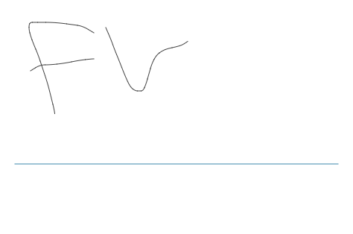

**NOTES**