|  |  |  |  |
| --- | --- | --- | --- |
| **Customer:** | DRASLOVKA MFGG XA05 G3 | **Location/Desc:** | MEMPHIS |
| **Address:** | US13 | **Performed by:** | JR Going |
|  | MEMPHIS,TN 38127-194 | **Date:** | 09/19/2024 |
| **Job/Order#** | 153435 |  |  |

|  |  |  |  |
| --- | --- | --- | --- |
| **Reason for call:** | Delivered 250 HP motor. | | |
| **Description of work:** |  | | |
| **Equipment and material used:** |  | | |
| **Recommended additional work:** |  | | |

|  |  |  |  |
| --- | --- | --- | --- |
| **Main Contact:** | Bud Neal | | |
| **Customer Signature:** |  | | |

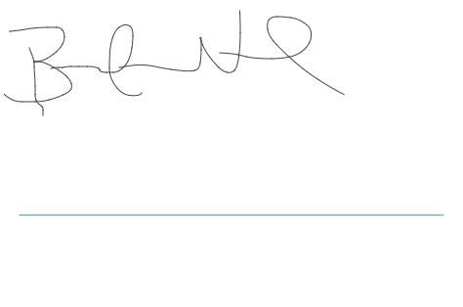

**NOTES**