|  |  |  |  |
| --- | --- | --- | --- |
| **Customer:** | ARCOSA MARINE | **Location/Desc:** | CARUTHERSVILLE |
| **Address:** | 265 COUNTY HWY 346 | **Performed by:** | JR Going |
|  | CARUTHERSVILLE,MO 63830 | **Date:** | 09/10/2024 |
| **Job/Order#** | 153474 |  |  |

|  |  |  |  |
| --- | --- | --- | --- |
| **Reason for call:** | Delivered hoist. | | |
| **Description of work:** |  | | |
| **Equipment and material used:** |  | | |
| **Recommended additional work:** |  | | |

|  |  |  |  |
| --- | --- | --- | --- |
| **Main Contact:** | Robert Chandler | | |
| **Customer Signature:** |  | | |

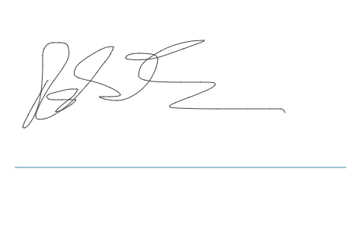

**NOTES**