|  |  |  |  |
| --- | --- | --- | --- |
| **Customer:** | Columbus McKinnon Corp | **Location/Desc:** | Lexington |
| **Address:** | 560 Rush Street | **Performed by:** | Justin Miller |
|  | Lexington,TN 38351 | **Date:** | 09/04/2024 |
| **Job/Order#** | 153404 |  |  |

|  |  |  |  |
| --- | --- | --- | --- |
| **Reason for call:** | DELEVIERING REPAIR FAN WITH NEW SHAFT | | |
| **Description of work:** |  | | |
| **Equipment and material used:** |  | | |
| **Recommended additional work:** |  | | |

|  |  |  |  |
| --- | --- | --- | --- |
| **Main Contact:** | Mark Gorden | | |
| **Customer Signature:** |  | | |

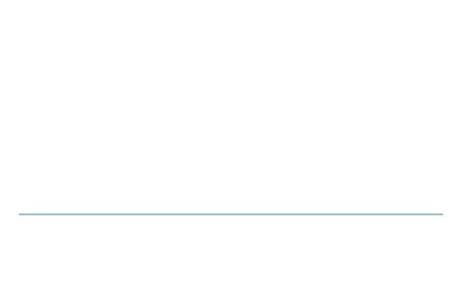

**NOTES**