|  |  |  |  |
| --- | --- | --- | --- |
| **Customer:** | DELTA PEANUT | **Location/Desc:** | JONESBORO |
| **Address:** | 9605 CW POST | **Performed by:** | JR Going |
|  | JONESBORO,AR 72401 | **Date:** | 09/03/2024 |
| **Job/Order#** | 153583 |  |  |

|  |  |  |  |
| --- | --- | --- | --- |
| **Reason for call:** | delivered shaft, blower, and coupling. | | |
| **Description of work:** |  | | |
| **Equipment and material used:** |  | | |
| **Recommended additional work:** |  | | |

|  |  |  |  |
| --- | --- | --- | --- |
| **Main Contact:** | Jordan Loyd | | |
| **Customer Signature:** |  | | |

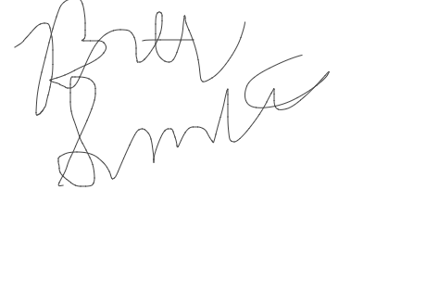

**NOTES**