|  |  |  |  |
| --- | --- | --- | --- |
| **Customer:** | Modine | **Location/Desc:** | Grenada |
| **Address:** | 3984 Hwy 51 S | **Performed by:** | JR Going |
|  | Grenada,MS 38901 | **Date:** | 08/20/2024 |
| **Job/Order#** |  |  |  |

|  |  |  |  |
| --- | --- | --- | --- |
| **Motor Pickup:** | Picked up 2 hoists for inspection and quote. **NOTES** | | |

|  |  |  |  |
| --- | --- | --- | --- |
| **Main Contact:** | Paul Mitchell | | |
| **Customer Signature:** |  | | |

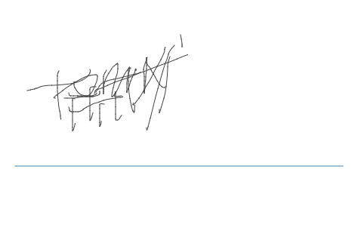

**NOTES**