|  |  |  |  |
| --- | --- | --- | --- |
| **Customer:** | AMERICAN KRAFT PAPER INDUSTRIE | **Location/Desc:** | Pine Bluff |
| **Address:** | 1701 JEFFERSON PARKWAY | **Performed by:** | Lee Pettey |
|  | Pine Bluff,AR 71602 | **Date:** | 08/15/2024 |
| **Job/Order#** | 101649 |  |  |

|  |  |  |  |
| --- | --- | --- | --- |
| **Reason for call:** | The plant was shut down and it took a while to deliver. The aerator motorless repair was delivered. | | |
| **Description of work:** |  | | |
| **Equipment and material used:** |  | | |
| **Recommended additional work:** |  | | |

|  |  |  |  |
| --- | --- | --- | --- |
| **Main Contact:** | Joel Collins | | |
| **Customer Signature:** |  | | |

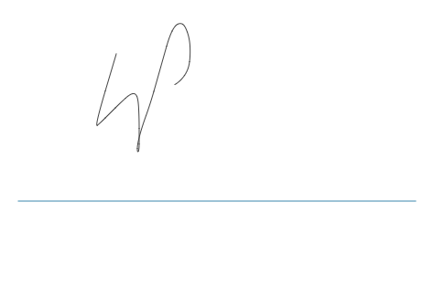

**NOTES**