|  |  |  |  |
| --- | --- | --- | --- |
| **Customer:** | MOUNTAIN VIEW WATER PLANT | **Location/Desc:** | Mountain View |
| **Address:** | 571 Ruddles Rd. | **Performed by:** | Lee Pettey |
|  | Mountain View,AR 72560 | **Date:** | 08/14/2024 |
| **Job/Order#** | 103167 |  |  |

|  |  |  |  |
| --- | --- | --- | --- |
| **Reason for call:** | delivered pump. I had the hardest time getting unloaded As they have few resources. I will check back to pick up a bigger pump that could not be loaded today. | | |
| **Description of work:** |  | | |
| **Equipment and material used:** |  | | |
| **Recommended additional work:** |  | | |

|  |  |  |  |
| --- | --- | --- | --- |
| **Main Contact:** | Jesse Dandridge | | |
| **Customer Signature:** |  | | |

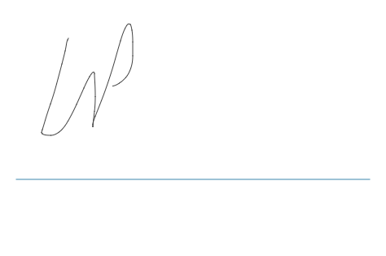

**NOTES**