|  |  |  |  |
| --- | --- | --- | --- |
| **Customer:** | GEORGIA PACIFIC GYPSUM | **Location/Desc:** | CUMBERLAND CITY |
| **Address:** | 150 TEMPLE DR | **Performed by:** | Kevin W Maxwell |
|  | CUMBERLAND CITY,TN 37050 | **Date:** | 08/13/2024 |
| **Job/Order#** |  |  |  |

|  |  |  |  |
| --- | --- | --- | --- |
| **Reason for call:** | Aegis meter shaft voltage test Aegis ring install and test | | |
| **Description of work:** | Performed Aegis meter shaft voltage test Aegis ring install and test Found zero volts before and after installing Aegis ring. | | |
| **Equipment and material used:** |  | | |
| **Recommended additional work:** |  | | |

|  |  |  |  |
| --- | --- | --- | --- |
| **Main Contact:** | michael treat | | |
| **Customer Signature:** |  | | |

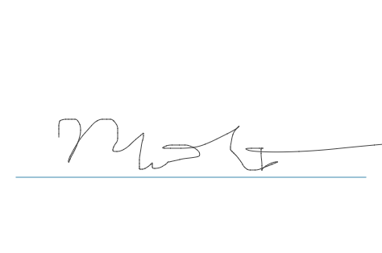

**NOTES**