|  |  |  |  |
| --- | --- | --- | --- |
| **Customer:** | BIG RIVER STEEL | **Location/Desc:** | Osceola |
| **Address:** | 1425 Ohlendorf Rd. | **Performed by:** | JR Going |
|  | Osceola,AR 72370 | **Date:** | 08/13/2024 |
| **Job/Order#** | 153230 |  |  |

|  |  |  |  |
| --- | --- | --- | --- |
| **Reason for call:** | delivered 200 HP motor. | | |
| **Description of work:** |  | | |
| **Equipment and material used:** |  | | |
| **Recommended additional work:** |  | | |

|  |  |  |  |
| --- | --- | --- | --- |
| **Main Contact:** | Justin Fish | | |
| **Customer Signature:** |  | | |

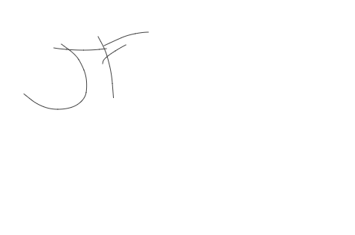

**2024-08-27 07:33:18**  
motor was delivered no in invoicing (JMM)