|  |  |  |  |
| --- | --- | --- | --- |
| **Customer:** | Ammunition Operations, LLC | **Location/Desc:** | Lonoke |
| **Address:** | 2592 Arkansas Hwy 15 N | **Performed by:** | Lee Pettey |
|  | Lonoke,AR 72086 | **Date:** | 08/13/2024 |
| **Job/Order#** |  |  |  |

|  |  |  |  |
| --- | --- | --- | --- |
| **Motor Pickup:** | Picked up two motors for eval **NOTES** | | |

|  |  |  |  |
| --- | --- | --- | --- |
| **Main Contact:** |  | | |
| **Customer Signature:** |  | | |

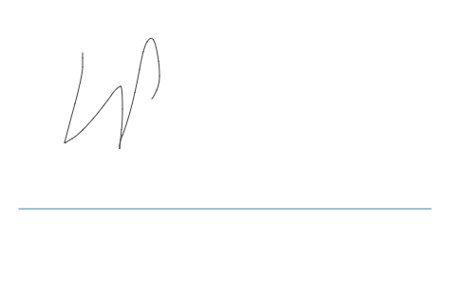

**NOTES**