|  |  |  |  |
| --- | --- | --- | --- |
| **Customer:** | UNIVERSITY OF MISSISSIPPI | **Location/Desc:** | Oxford |
| **Address:** | Gertrude Ford Blvd | **Performed by:** | JR Going |
|  | Oxford,MS | **Date:** | 08/08/2024 |
| **Job/Order#** | 153314 |  |  |

|  |  |  |  |
| --- | --- | --- | --- |
| **Reason for call:** | delivered and installed 1,000 HP motor. Drew smith | | |
| **Description of work:** |  | | |
| **Equipment and material used:** |  | | |
| **Recommended additional work:** |  | | |

|  |  |  |  |
| --- | --- | --- | --- |
| **Main Contact:** |  | | |
| **Customer Signature:** |  | | |

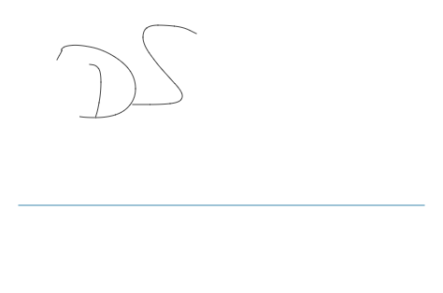

**NOTES**