|  |  |  |  |
| --- | --- | --- | --- |
| **Customer:** | MARTIN & WHITE MECHANICAL | **Location/Desc:** | MILLINGTON |
| **Address:** | 5501 OLD MILLINGTON RD | **Performed by:** | Kevin W Maxwell |
|  | MILLINGTON,TN 38053 | **Date:** | 08/07/2024 |
| **Job/Order#** | 153377 |  |  |

|  |  |  |  |
| --- | --- | --- | --- |
| **Reason for call:** | Laser alignment | | |
| **Description of work:** | Performed laser alignment on CT2 at the 3131 Democrat RD Fed Ex Building. | | |
| **Equipment and material used:** | 12 B shims | | |
| **Recommended additional work:** |  | | |

|  |  |  |  |
| --- | --- | --- | --- |
| **Main Contact:** | Van Roseberry | | |
| **Customer Signature:** |  | | |

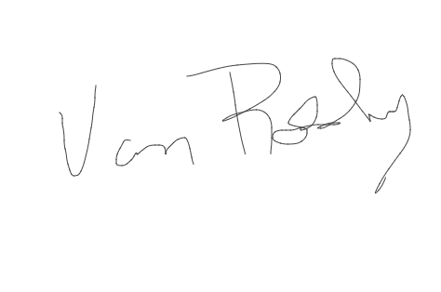

**NOTES**