|  |  |  |  |
| --- | --- | --- | --- |
| **Customer:** | Hi-Speed Industrial Service | **Location/Desc:** | Millington |
| **Address:** | 7030 Ryburn Drive | **Performed by:** | Justin Miller |
|  | Millington,TN 38053 | **Date:** | 07/31/2024 |
| **Job/Order#** |  |  |  |

|  |  |  |  |
| --- | --- | --- | --- |
| **Reason for call:** | Test activity | | |
| **Description of work:** |  | | |
| **Equipment and material used:** |  | | |
| **Recommended additional work:** |  | | |

|  |  |  |  |
| --- | --- | --- | --- |
| **Main Contact:** | Ben Buffington | | |
| **Customer Signature:** |  | | |

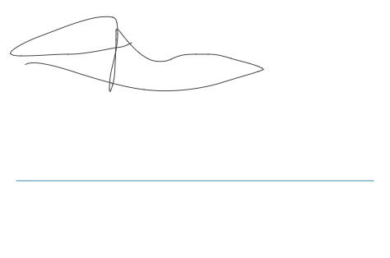

**NOTES**