|  |  |  |  |
| --- | --- | --- | --- |
| **Customer:** | United Solutions | **Location/Desc:** | Sardis |
| **Address:** | 1052 Industrial Park Rd | **Performed by:** | JR Going |
|  | Sardis,MS 38666 | **Date:** | 07/25/2024 |
| **Job/Order#** |  |  |  |

|  |  |  |  |
| --- | --- | --- | --- |
| **Motor Pickup:** | Picked up 2 400 hp motors. **NOTES** | | |

|  |  |  |  |
| --- | --- | --- | --- |
| **Main Contact:** | Michael Howell | | |
| **Customer Signature:** |  | | |

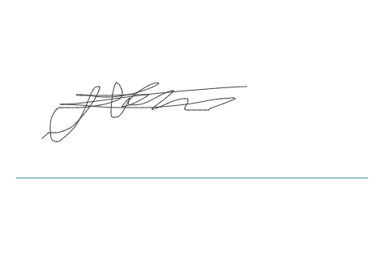

**NOTES**