|  |  |  |  |
| --- | --- | --- | --- |
| **Customer:** | NUCOR STEEL MEMPHIS INC. | **Location/Desc:** | Memphis |
| **Address:** | 3601 Paul R Lowry Road | **Performed by:** | Joseph Shurtz |
|  | Memphis,TN 38109 | **Date:** | 03/11/2024 |
| **Job/Order#** | 152300 |  |  |

|  |  |  |  |
| --- | --- | --- | --- |
| **Reason for call:** | Balance baghouse middle fan on south side | | |
| **Description of work:** | Balance baghouse middle fan on south side | | |
| **Equipment and material used:** |  | | |
| **Recommended additional work:** |  | | |

|  |  |  |  |
| --- | --- | --- | --- |
| **Main Contact:** | Chris Anderson | | |
| **Customer Signature:** |  | | |

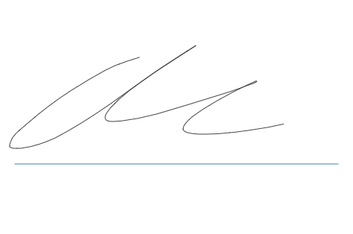

**2024-03-26 11:46:59**  
FOLLOWING UP ON SECOND REQUEST (JMM) **2024-03-19 15:26:23**  
delivery ticket submitted for PO request (JMM) **2024-03-18 10:46:17**  
create delivery ticket for PO request(JMM)