|  |  |  |  |
| --- | --- | --- | --- |
| **Customer:** | USG Interiors (QS work) | **Location/Desc:** | Greenville |
| **Address:** | 850 No. Broadway | **Performed by:** | Kevin W Maxwell |
|  | Greenville,MS 38701 | **Date:** | 03/07/2024 |
| **Job/Order#** | 152273 |  |  |

|  |  |  |  |
| --- | --- | --- | --- |
| **Reason for call:** | Monthly vibration IR surveys | | |
| **Description of work:** | Performed March 2024 Monthly vibration IR surveys Detailed report to follow | | |
| **Equipment and material used:** |  | | |
| **Recommended additional work:** |  | | |

|  |  |  |  |
| --- | --- | --- | --- |
| **Main Contact:** | John Wright | | |
| **Customer Signature:** |  | | |

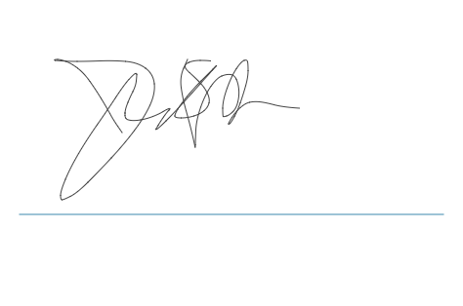

**2024-03-26 12:58:40**  
add po (BJB) **2024-03-26 11:22:39**  
BILLING WEEK OF 3/25(JMM) **2024-03-19 15:26:59**  
awaiting report upload estimated completion 3/20(JMM)