|  |  |  |  |
| --- | --- | --- | --- |
| **Customer:** | Tetra Technologies | **Location/Desc:** | West Memphis |
| **Address:** | 2201 Port Road | **Performed by:** | Joseph Shurtz |
|  | West Memphis,AR 72301 | **Date:** | 03/04/2024 |
| **Job/Order#** | 152215 |  |  |

|  |  |  |  |
| --- | --- | --- | --- |
| **Reason for call:** | Perform quarterly vibration route | | |
| **Description of work:** | Perform quarterly vibration route | | |
| **Equipment and material used:** |  | | |
| **Recommended additional work:** |  | | |

|  |  |  |  |
| --- | --- | --- | --- |
| **Main Contact:** | Craig Lindsey | | |
| **Customer Signature:** |  | | |

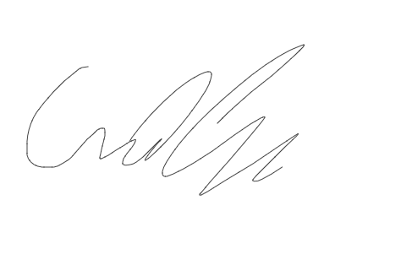

**2024-03-26 11:42:33**  
INVOICING WEEK 3/25(JMM) **2024-03-19 15:47:39**  
In billing process (JMM) **2024-03-15 20:53:34**  
Ready to bill (JTW)