|  |  |  |  |
| --- | --- | --- | --- |
| **Customer:** | Morgan & Thornburg, Inc. | **Location/Desc:** | Memphis |
| **Address:** | 4076 Hatcher Circle | **Performed by:** | Joseph Shurtz |
|  | Memphis ,TN 38118 | **Date:** | 12/01/2023 |
| **Job/Order#** | 151619 |  |  |

|  |  |  |  |
| --- | --- | --- | --- |
| **Reason for call:** | Balance fan at Mississippi blvd. church | | |
| **Description of work:** | Balance fan at Mississippi blvd. church | | |
| **Equipment and material used:** |  | | |
| **Recommended additional work:** |  | | |

|  |  |  |  |
| --- | --- | --- | --- |
| **Main Contact:** | Rusty Acklin | | |
| **Customer Signature:** |  | | |

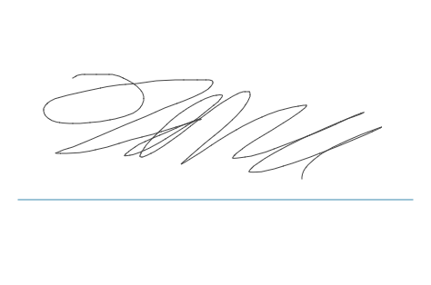

**2023-12-05 10:53:15**  
PO RECEIVED MARKED READY TO INVOICE IN TRACKER (JMM) **2023-12-04 11:16:05**  
Delivery ticket created and submitted (JMM)