|  |  |  |  |
| --- | --- | --- | --- |
| **Customer:** | LOUIS DREYFUS COMPANY | **Location/Desc:** | WEST MEMPHIS |
| **Address:** | RIVER ELEVATORS LLC | **Performed by:** | Kevin W Maxwell |
|  | WEST MEMPHIS ,AR 72301 | **Date:** | 11/30/2023 |
| **Job/Order#** | 151564 |  |  |

|  |  |  |  |
| --- | --- | --- | --- |
| **Reason for call:** | Annual vibration analysis | | |
| **Description of work:** | Performed annual vibration analysis on 705 and Take up gear drives and drive motors. Detailed report to follow | | |
| **Equipment and material used:** |  | | |
| **Recommended additional work:** |  | | |

|  |  |  |  |
| --- | --- | --- | --- |
| **Main Contact:** | Derreck Smith | | |
| **Customer Signature:** |  | | |

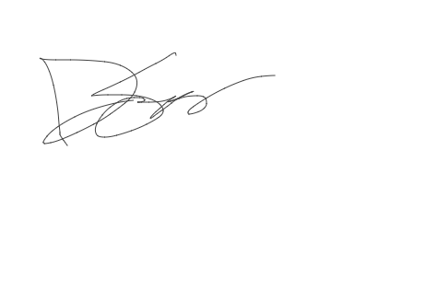

**2023-12-07 10:47:55**  
PREPPED AND READY IN TRACKER (JMM) **2023-12-04 08:26:56**  
BILLING WEEK OF 12/4(JMM)