|  |  |  |  |
| --- | --- | --- | --- |
| **Customer:** | GRAMMER INC | **Location/Desc:** | SHANNON |
| **Address:** | 231 LANEY ROAD | **Performed by:** | Joseph Shurtz |
|  | SHANNON ,MS 38868 | **Date:** | 08/14/2023 |
| **Job/Order#** | 150848 |  |  |

|  |  |  |  |
| --- | --- | --- | --- |
| **Reason for call:** | Preform quarterly vibration and oil analysis | | |
| **Description of work:** | Preform quarterly vibration and oil analysis | | |
| **Equipment and material used:** | Blackstone labs oil analysis kit | | |
| **Recommended additional work:** |  | | |

|  |  |  |  |
| --- | --- | --- | --- |
| **Main Contact:** | Scott Bratton | | |
| **Customer Signature:** |  | | |

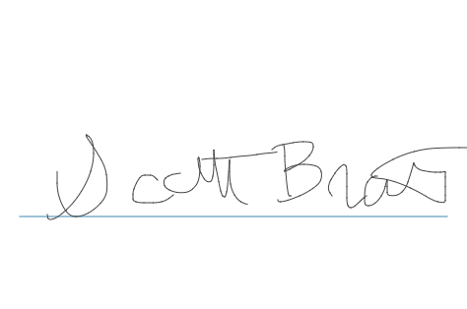

**NOTES**