|  |  |  |  |
| --- | --- | --- | --- |
| **Customer:** | RELIANT ATLANTIC GROUP LLC | **Location/Desc:** | BRANDON |
| **Address:** | 233 CHRIS LANE | **Performed by:** | Kevin W Maxwell |
|  | BRANDON ,MS 39047 | **Date:** | 08/04/2023 |
| **Job/Order#** | 150773 |  |  |

|  |  |  |  |
| --- | --- | --- | --- |
| **Reason for call:** | Quarterly Vibration-Infrared Survey on Ammonia Compressors and Drive motor MCCâs | | |
| **Description of work:** | Performed Quarterly Vibration-Infrared Survey on Ammonia Compressors and Drive motor MCCâs   Detailed report to follow | | |
| **Equipment and material used:** |  | | |
| **Recommended additional work:** |  | | |

|  |  |  |  |
| --- | --- | --- | --- |
| **Main Contact:** | Tim Busby | | |
| **Customer Signature:** |  | | |

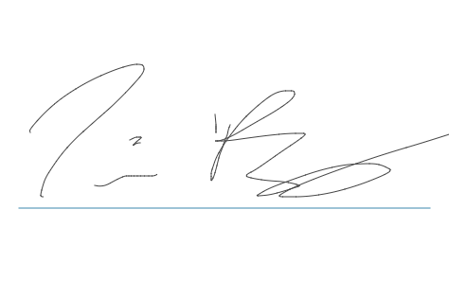

**NOTES**