Maximizing Reliability of Rotating Equipment

Almatis-Tabular
Data Survey: 30-September-2024
Analysis: 18-October-2024
Report: 18-October-2024
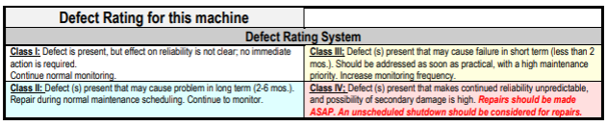

The Almatis Tabular report is attached.
Please note that the Cooling Bin Fans are an area of concern on this report.
It appears the customer was able to mitigate a number of issues from the last report.
There are four Class IV defects, five Class III defects, three Class II defects, and three Class I defects noted on the report.

#7 Ball Former – Motor Bearing or Shaft Looseness - Class IV Defect
The #7 Ball Former shows vibration at harmonics of motor running speed on the motor (top chart). This is indicative of slop in the bearing or shaft. The gearbox shows irregular waveform and a matching spectrum indicative an effect on the input shaft (bottom chart). Check motor shaft, bearing, and coupling condition. The issue on the motor may have contributed to wear on the input gearset. Take a gearbox oil sample.
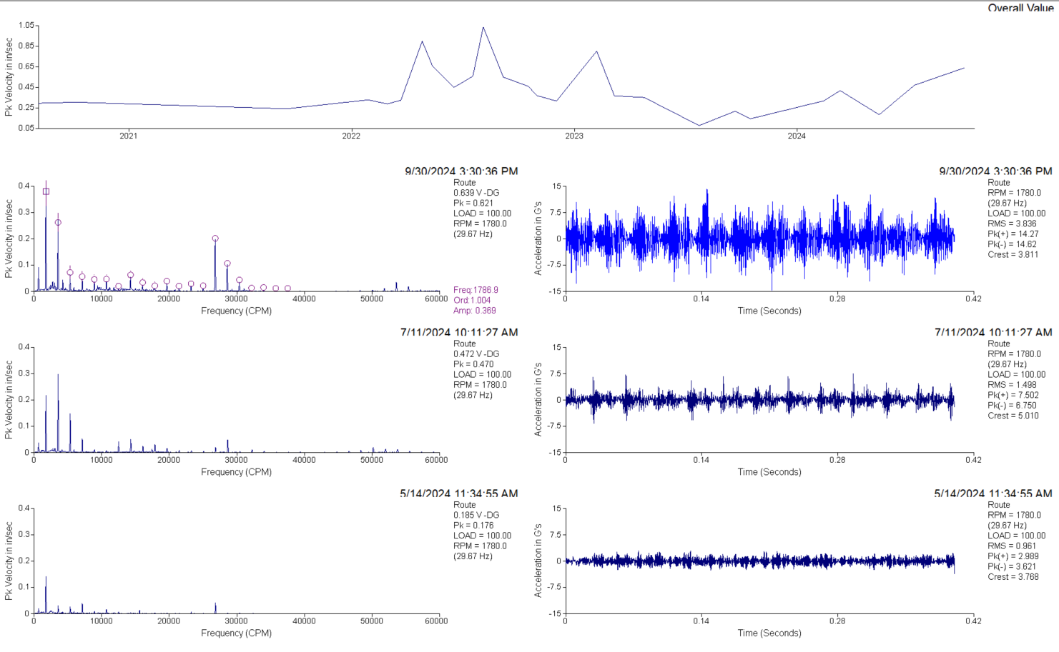
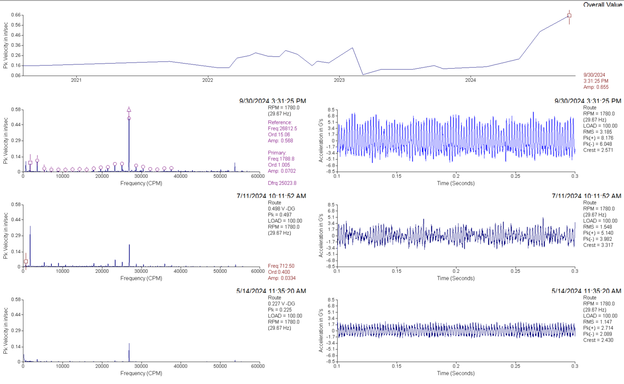
#9 Ball Former – Output Gearset Wear Class II Defect
The #9 Ball Former motor, drive side bearing continues to show some minor signs of looseness, but improved over May and August. Increasing output gear noise is masking readings on the machine. Check gearbox oil levels and oil condition. Take an oil sample to diagnose any worn components within the gearbox.
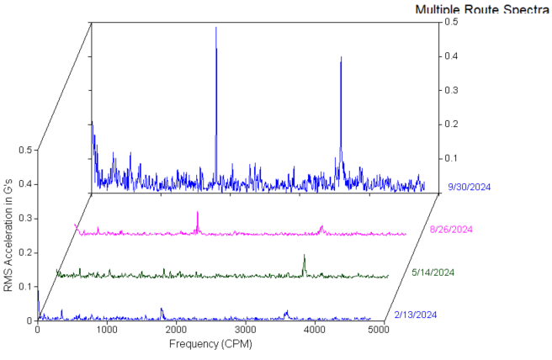
#11 A Cooling Bin Fan – Fan Bearings - Class IV Defect
The #11A Cooling Bin Fan shows looseness in the waveform (right) and high frequency noise indicative of roughening bearing contact surfaces. Plan to replace the fan bearings soon. Check for proper sheave alignment and belt tension during the repair.
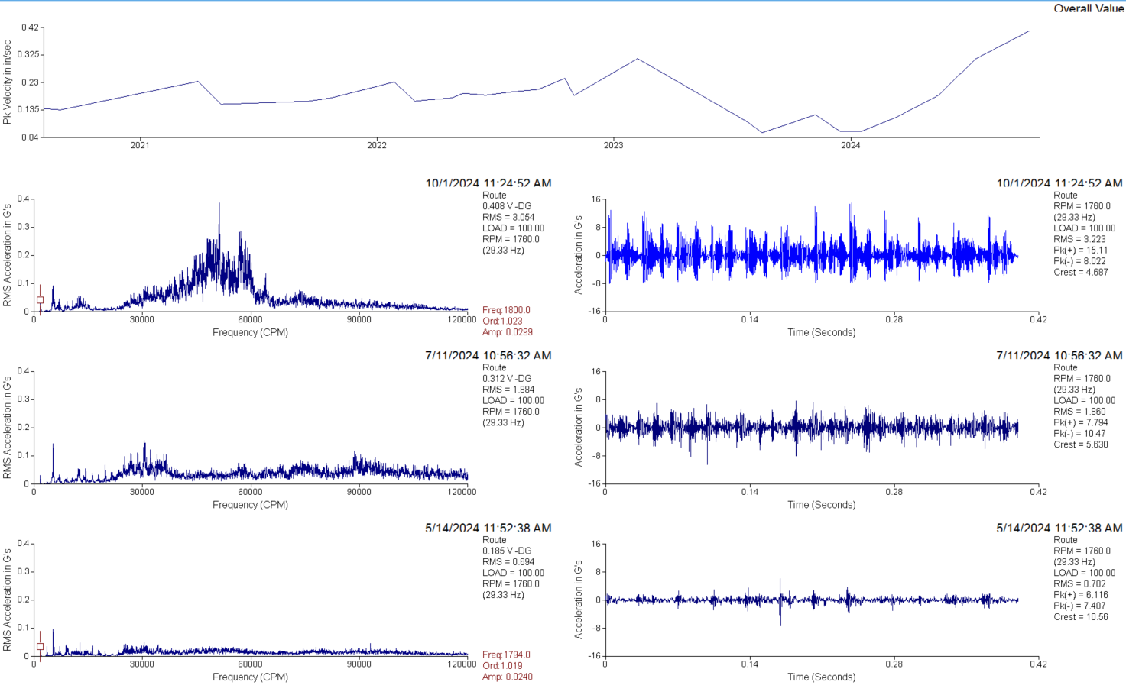
#12 A Cooling Bin Fan – Fan Bearings - Class III Defect
The #12 A Cooling Bin Fan, non-drive end fan bearing shows increasing signs of looseness. Running speed harmonics can be seen in the spectra (left) and impacting can be seen in the waveform (right). Inspect for looseness in the bearing, between the bearing outer race and bearing housing, and between the shaft and bearing inner race.
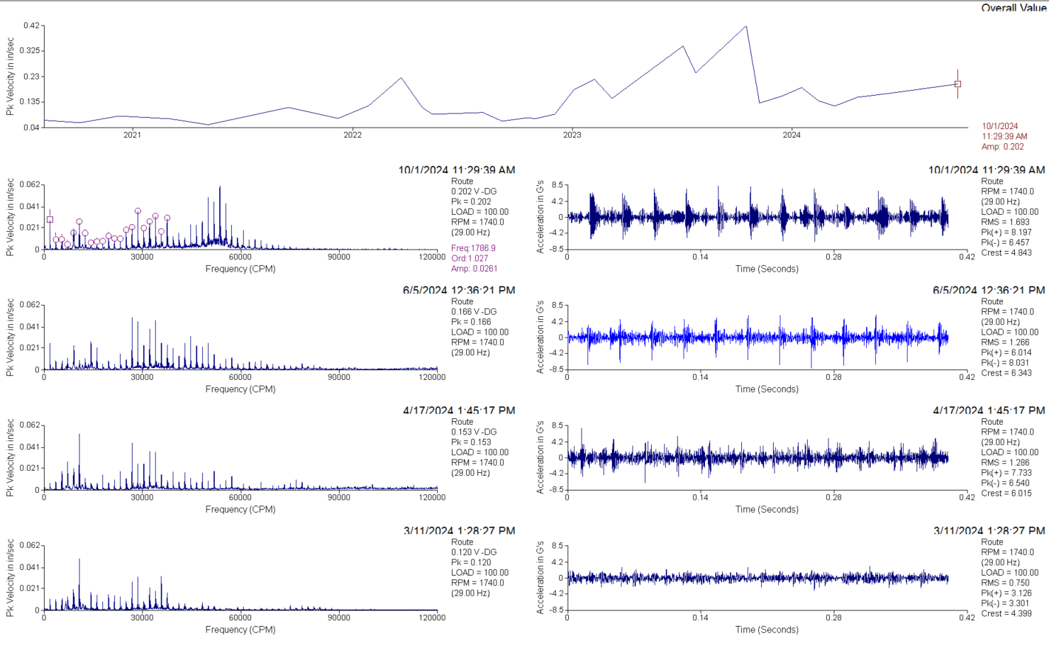
Tabular #12 B Cooling Bin Fan – Fan Bearing Wear Class III Defect
This equipment was not measured during the late September/early October visit.
The #12 B Cooling Bin Fan, outboard fan bearing, shows increasing signs of bearing wear. A high frequency “haystack” of vibration increased in amplitude in June. In August the haystack had shifted to lower frequencies and greater, more defined amplitudes. This is indicative of bearing defects increasing in size. Lubricate this bearing and monitor for increased temperature, noise, and looseness.
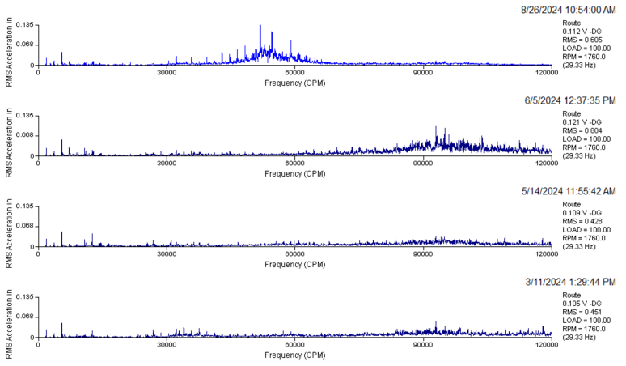
Tabular #13 A Cooling Bin Fan – Fan Bearing Wear Class II Defect
The #13 A Cooling Bin Fan, outboard fan bearing, continues to show an increase in low amplitude, high frequency vibration indicative of under lubrication or early bearing wear. Non-synchronous peaks indicative of bearing component noise can be seen growing to the left. Lubricate this bearing and monitor for increased noise and temperature. Have a replacement bearing on hand and a plan to replace it.
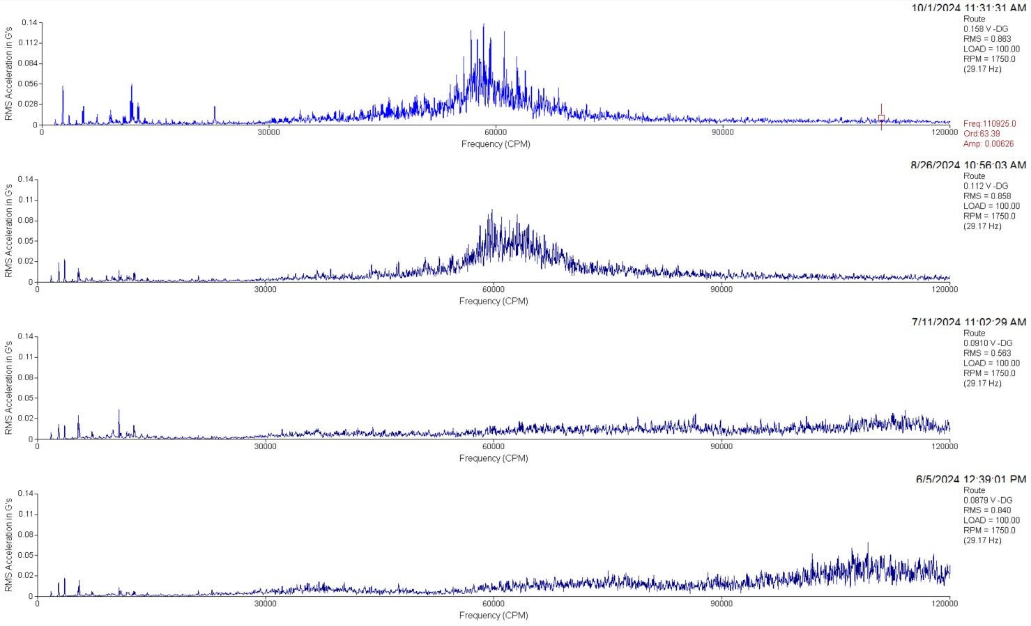
Tabular #14 B Cooling Bin Fan – Bearing Cocked or Bent Shaft Class III Defect
This equipment was not measured during the late September/early October survey.
The #14 B Cooling Bin Fan shows an increase in 2x running speed vibration along the shaft axis, indicative of a cocked bearing on a shaft, a bent shaft, or coupling misalignment. This increased stress appears to be driving looseness in the fan bearings starting sometime in winter ’23-‘24. Inspect the coupling alignment and bearing condition. More than one issue is suspected on this fan.
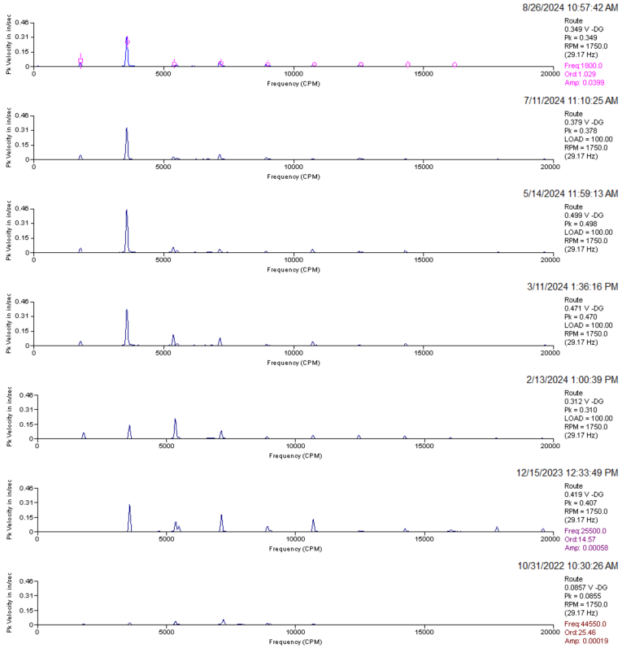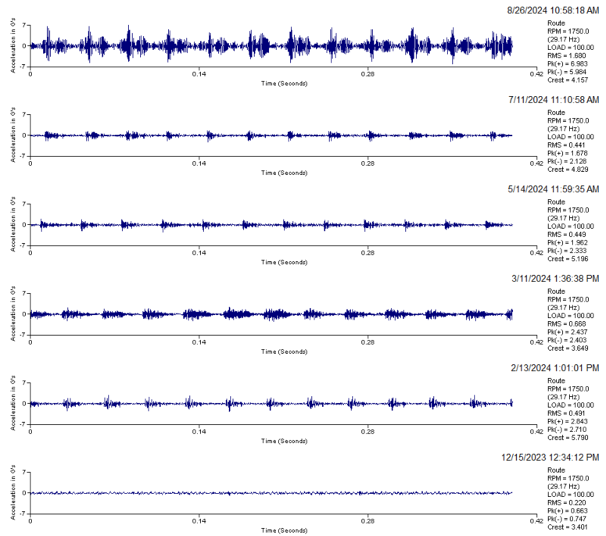
Tabular #11 Converter I.D. Fan – Inboard Fan Bearing Looseness Class IV Defect
This equipment was not measured during the late September/early October survey.
The #11 Converter I.D. Fan, inboard fan bearing shows a significant increase in periodic vibration in the waveform and broad spectrum frequencies indicative of progressive bearing looseness and bearing wear. Prepare to replace this bearing at the next opportunity.
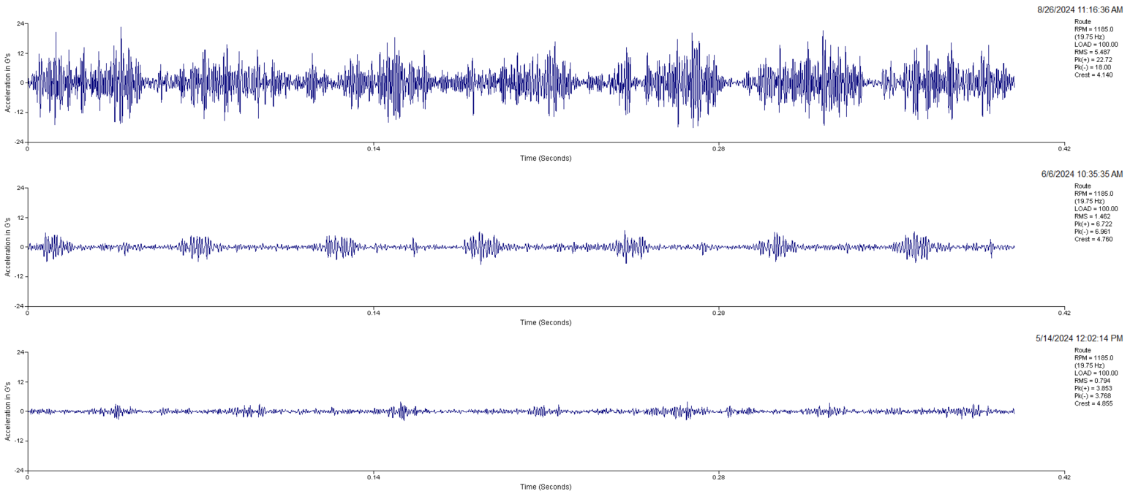
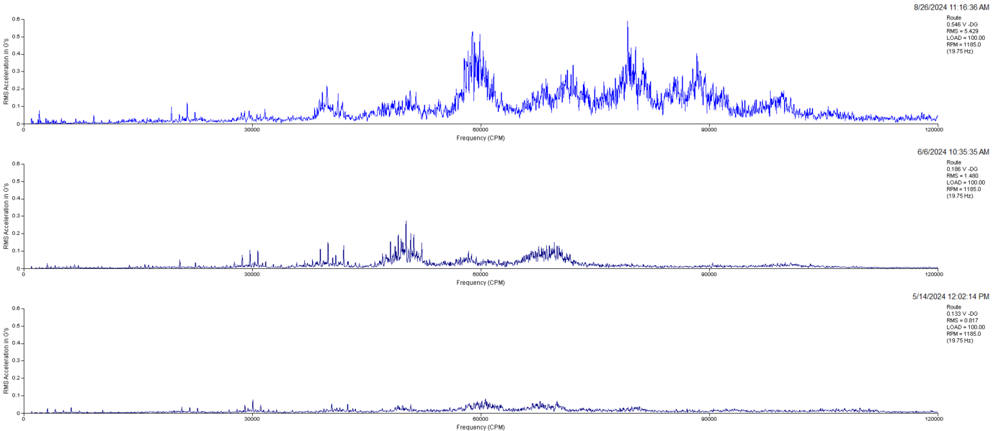
Tabular #12 Converter I.D. Fan – Outboard Fan Bearing Looseness Class I Defect
This equipment was not measured during the late September/early October survey.
The #12 Converter I.D. Fan, outboard fan bearing has a long and relatively stable history of vibration indicative of looseness. It has increased above its “normal” levels between 6-6-24 and 8-26-24. This may not be a concern if these are split race style bearings as these normally show looseness due to their design. Inspect the bearings for high temperature, vibration, noise, and signs of looseness.
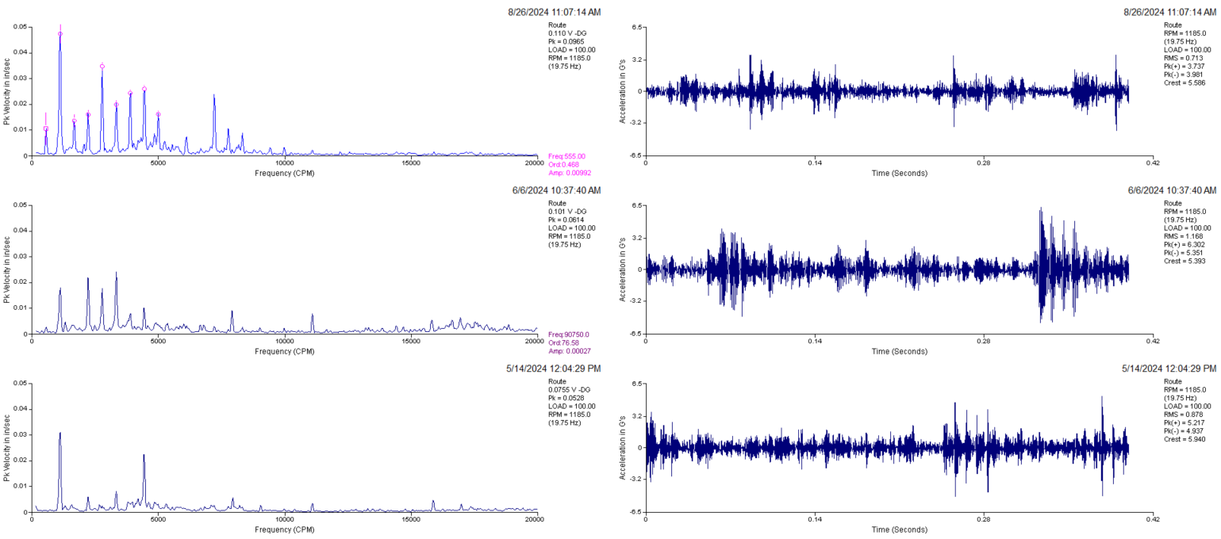

Tabular #14 Converter I.D. Fan – Inboard Fan Bearing Class III Defect
Since winter ’23-’24, the #14 Converter I.D. Fan, inboard fan bearing shows a steady trend of increasing vibration indicative of bearing wear and looseness. Be prepared to replace the inboard fan bearing.
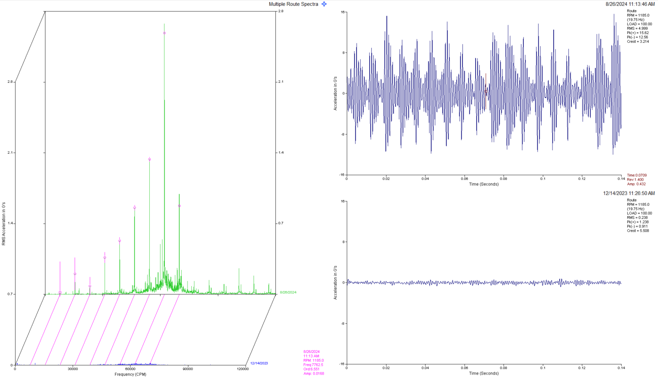
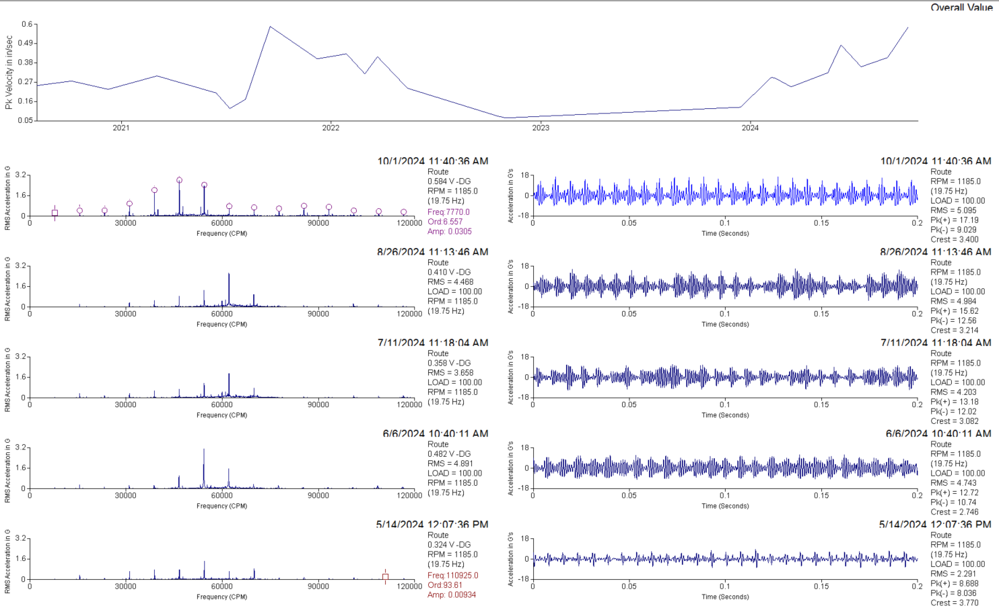
Tabular 106 Elevator – Gearbox Input Pinion Class I Defect
The 106 Elevator Gearbox, Input Pinion, has much improved from 8/26/2024 to 9/30/2024 but continues to show low amplitude impacting-like event 30 times per second, or about 1800 CPM. This is indicative of residual shaft and bearing looseness or a defect on one of the input pinion gear teeth. Regular oil analysis and monitoring of this equipment is recommended. If service was performed on the equipment during this time period, it was effective.
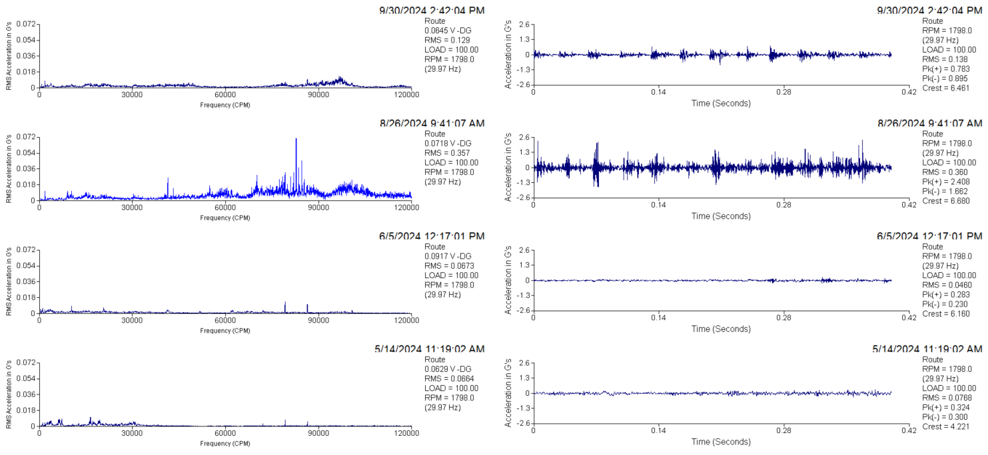
Tabular #4 Tabular D/C Fan – Fan Outboard Bearing Wear Class I Defect
The #4 Tabular D/C Fan, Outboard Fan Bearing, shows improvement between 8/26/2024 and 9/30/2024. Some impacting remains. Check shaft to bearing and bearing to housing fit. Monitor this equipment. If service was performed on this equipment, it appears to have been effective.
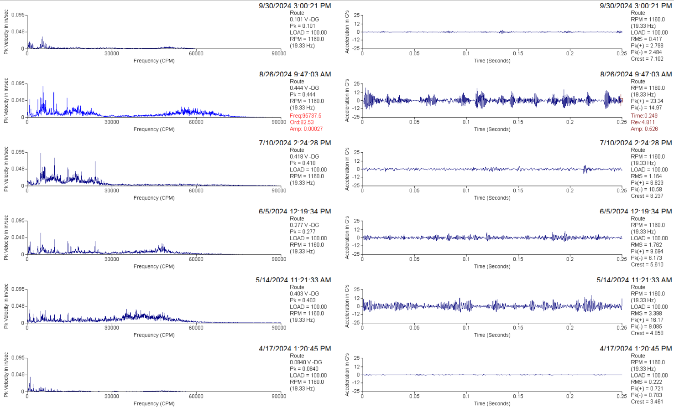
GRND.ORE D/C Fan – Fan Inboard Bearing Wear - Class IV Defect
The Grnd.Ore Dust Collector Fan, drive side bearing shows some signs of looseness (harmonics of running speed, left side of spectra) since at least 2-24. Looseness and high frequency indications of worn bearing races have increased as of 9-30-24. Replace this bearing at the next opportunity. Monitor regularly until then. Lubricate and monitor for oil leaking out of the bearing (separating grease), temperature, noise, and noticeable vibration.
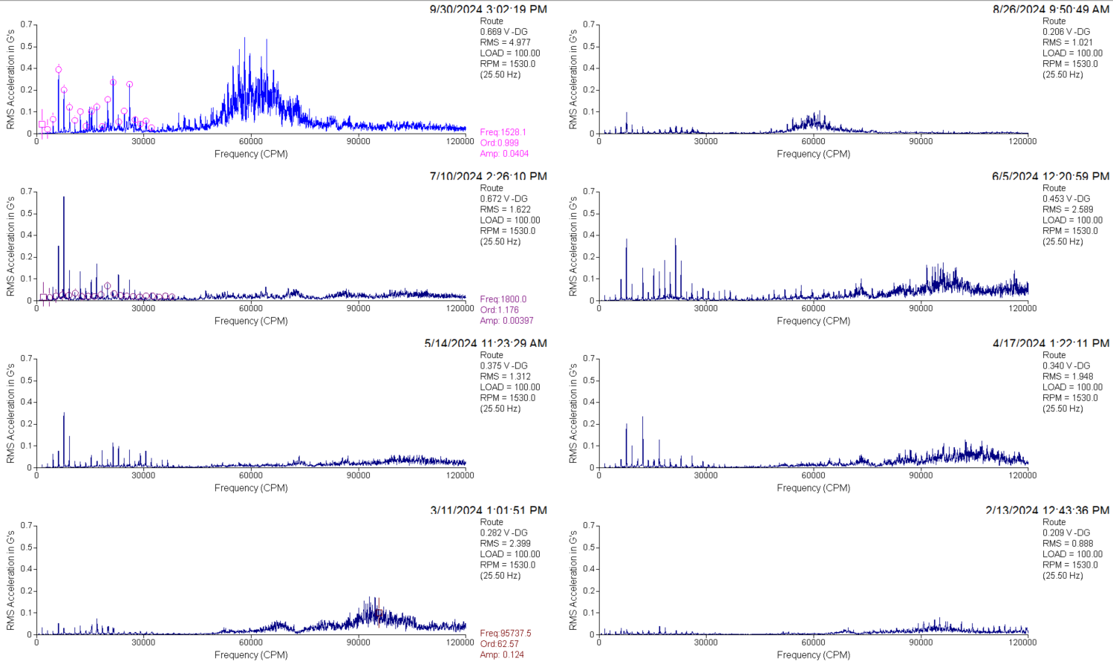
101 UNG. Elevator – Input Pinion - Class II Defect
The 101 UNG Elevator shows an increase in apparent gear noise. Check motor to gearbox coupling and motor mounting. Check oil level and condition. Take an oil sample for analysis.
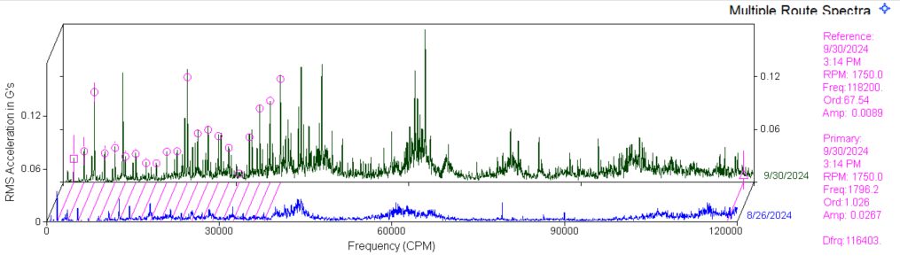
UNGRND.ORE D/C Fan – Unbalance - Class III Defect
The UNGRND.ORE Dust Collector Fan shows a sudden increase in running speed vibration and an increase in minor signs of looseness to possible significant looseness and impacting. Thoroughly clean and inspect the fan rotor and sheaves. Inspect for erosion, missing or thrown weights, and any loose components. Inspect structure for looseness or damage. Inspect for loose fit between the shaft, bearings, and bearing pillow block mounting. If cleaning and basic repairs do not reduce obvious vibration, the fan may need to be balanced.
