Maximizing Reliability of Rotating Equipment

Almatis-Calcine
Data Survey: 1-October-2024
Analysis: 11-October-2024
Report: 11-October-2024
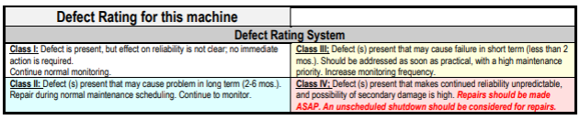
Attached is the Almatis-Calcine vibration report for data collected on 9-30 and 10-1-24.
Please note that #2 Primary Fan and #4 Primary Fan have been removed from the report due to improved conditions.
No new data was collected for #9 Dust Collector.
This report contains two Class IV faults, eight Class III faults, two Class II faults, and one Class I fault.
Calcine Air Slide Blower – Fan Unbalance Class III Defect
The Calcine Air Slide Blower continues to show increased low speed vibration suspected to be fan rotor unbalance. Clean all residue from the fan rotor. Inspect for thrown weights, erosion, or other issues that would change the weight distribution on the fan rotor. If this does not resolve the issue, consider having the fan balanced.
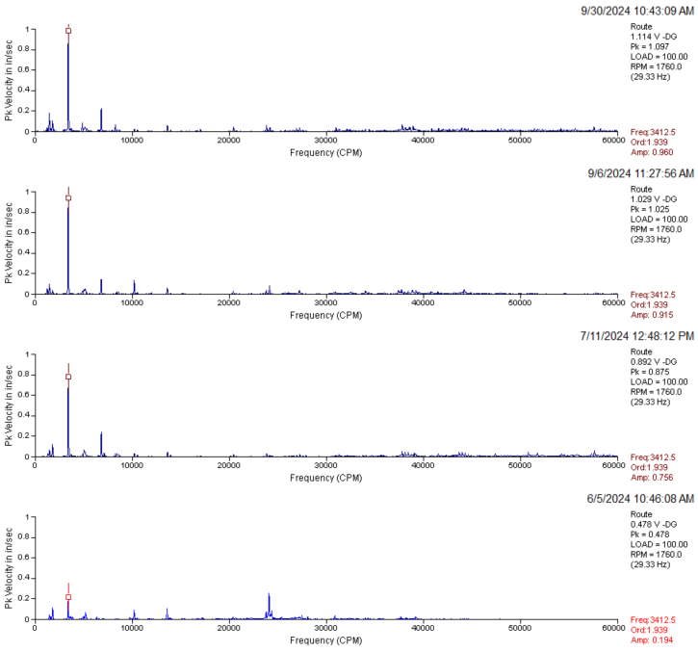

Calcine Unloading Lift Blower – Motor Bearings Class III Defect
The Calcine Air Slide Blower shows indications of rotor bar issues. High energy at 120hz (7200CPM) and a “loping” in the waveform at ~150CPM are indicated on the drive side. Very high amplitude acceleration with a truncated form (-10g with a round trough, +20-30 with a sharp peak) on the non-drive side indicate a belt issue. The motor housing may be twisted by uneven mounting leading to an inconsistent air gap causing 2x line frequency vibrations. Check the motor mounting. Ensure proper mounting and belt tension. Check sheaves for issues. Monitor for high amperage draw and other electrical issues.
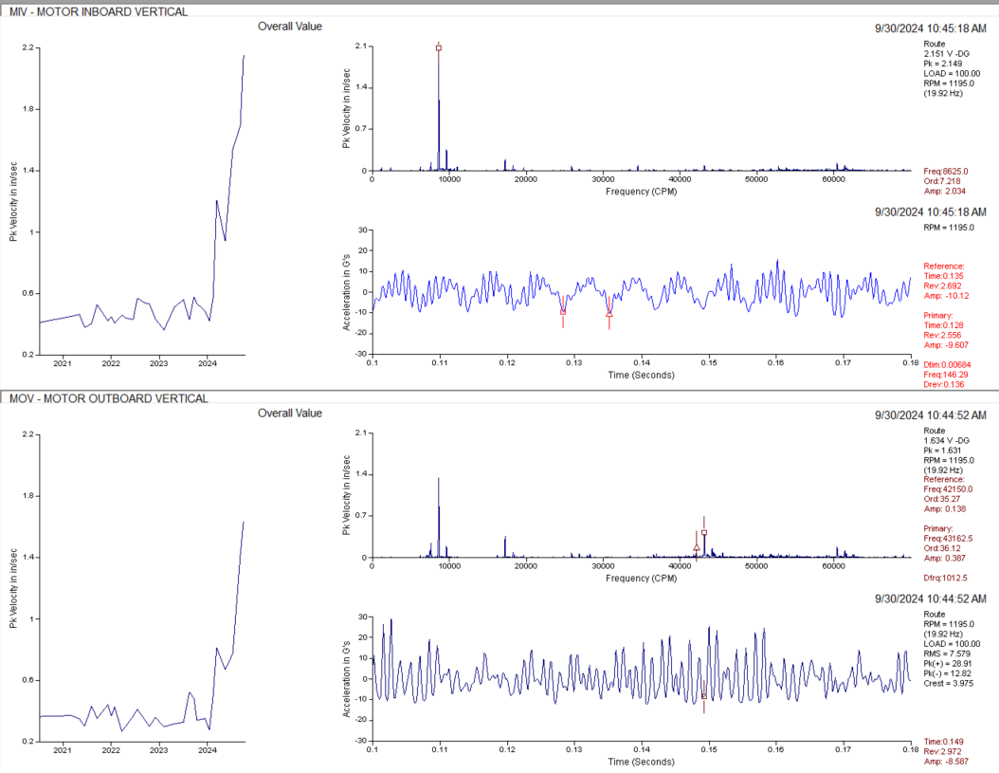
Calcine #1 Leach Water Pump V/S – Motor Bearings Class VI Defect
The #1 Leach Water Pump V/S shows increasing signs of impacting and looseness in the motor bearings (see spikes in waveform on the right) as well as broad frequency “haystacks” in the vibration spectrum indicative of roughening bearing surfaces (left). Rebuild this motor at the next opportunity.
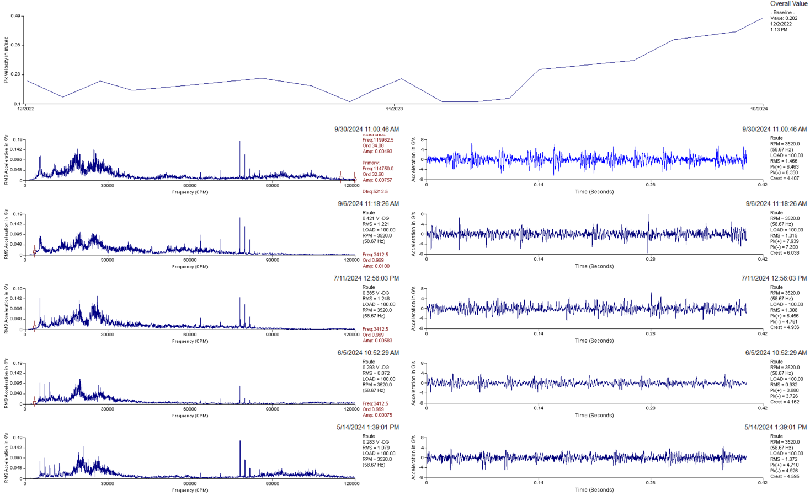
#3 Wash Water Pump – Pump Bearing Fault - Class III Defect
The #3 Wash Water Pump, drive side bearing, shows impacting in the waveform and suspected bearing harmonics in the spectrum. This indicates looseness in the bearing. Plan to replace the pump or rebuild it with new bearings.

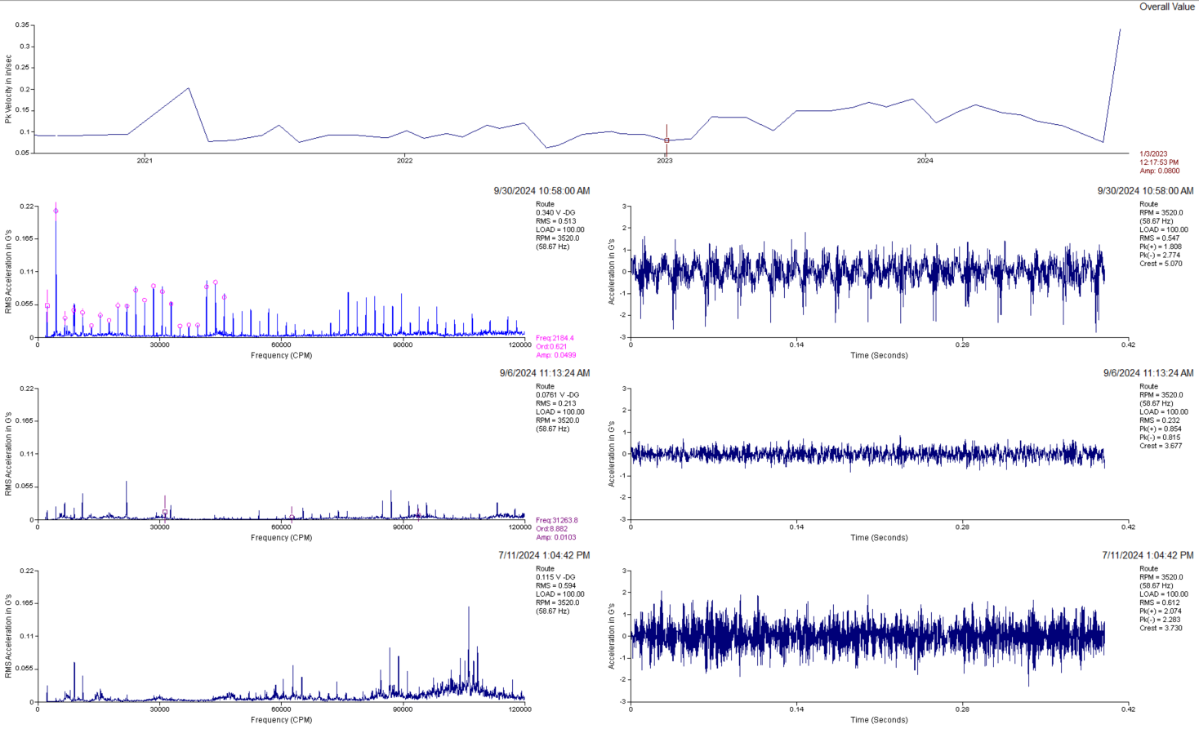
#3 Wash Water Pump – Pump Bearing Fault - Class III Defect
The #3 Wash Water Pump started showing minor signs of bearing defects on the non-drive end pump bearing in June and July ’24. Haystacks and peaks with sidebands can be seen on the spectrum (left) that indicate bearing rolling element wear. Impacting was evident on 9-30-24 in the waveform (right) that indicates surface wear has become minor looseness. Bearing condition will likely continue to degrade. Be prepared to replace or rebuild this pump. Check for signs of water contamination in the bearings that might indicate a seal failure.
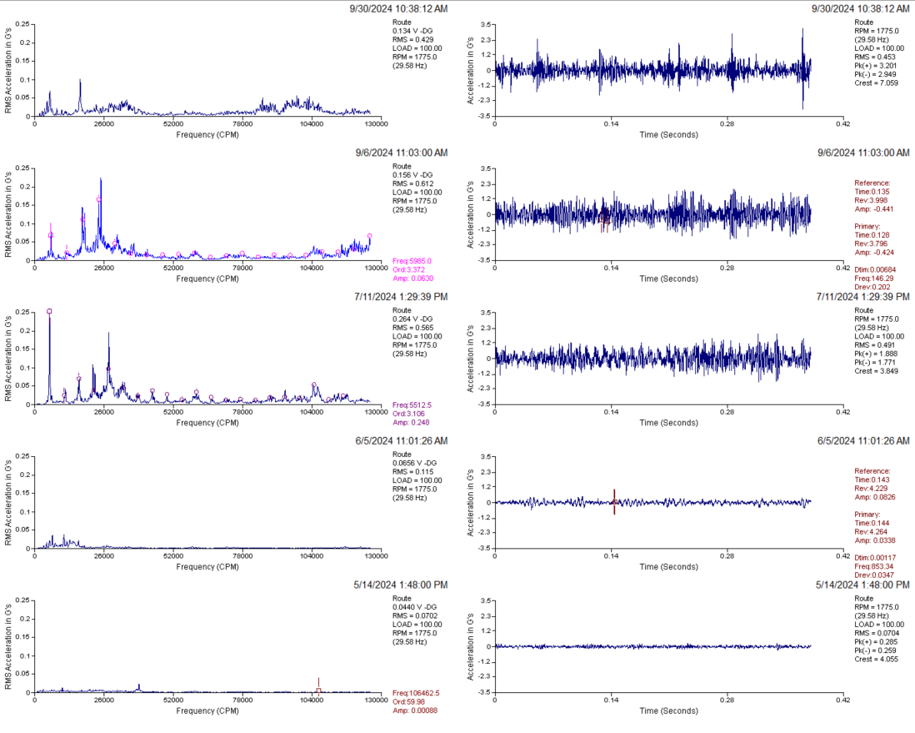
Calcine #2 Lift Blower – Motor Looseness Class III Defect
The #2 Lift Blower shows increasing vibration at what is likely twice motor turning speed. This may indicate a loose motor foot or supporting structure. Inspect the structure for issues. Check the fan coupling or sheaves for issues.

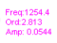
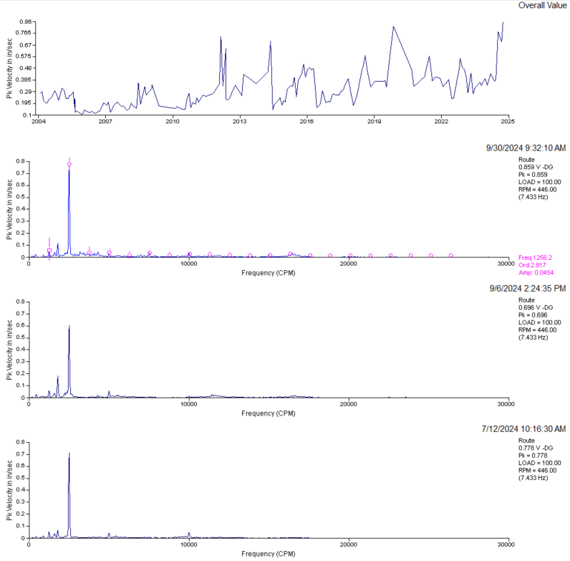
2-3x motor speed
Calcine #2 Lift Blower – Blower Bearing Wear Class III Defect
The #2 Lift Blower shows increased broad spectrum, high frequency vibration called “haystacking” on the blower bearings. This may indicate early wear. Overall reduced amplitudes on 9/30/2024 indicate the bearings may have been lubricated effecting an improvement. The bearings are still suspected to have sustained wear. Monitor for increased temperature, noise, and an increase in oil separated from the grease leaking out of the bearings. If this is bearing wear it may have been caused by the increased stress of the motor vibration issue mentioned earlier in this report.
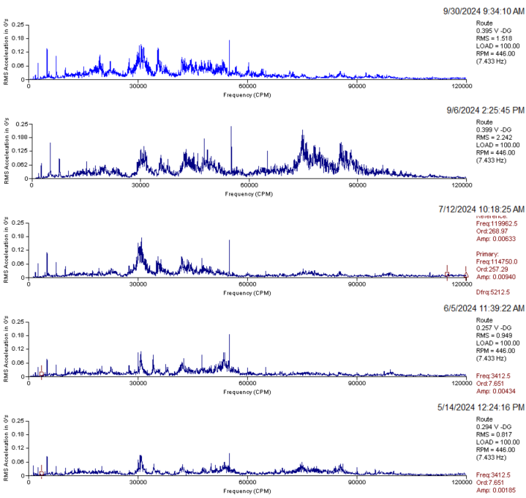

#3 ASB Unloading Lift Dust Collector Fan – Blower Bearing Wear - Class II Defect
The #3 ASB Unloading Lift Dust Collector Fan, fan drive end bearing, shows steadily increasing high frequency “haystacking” indicative of underlubrication and wear. Lubricate the fan bearings if that has not occurred since May ’24 and monitor for increased temperature, noise, and separated grease leaking from the bearing. Have a replacement bearing on hand.

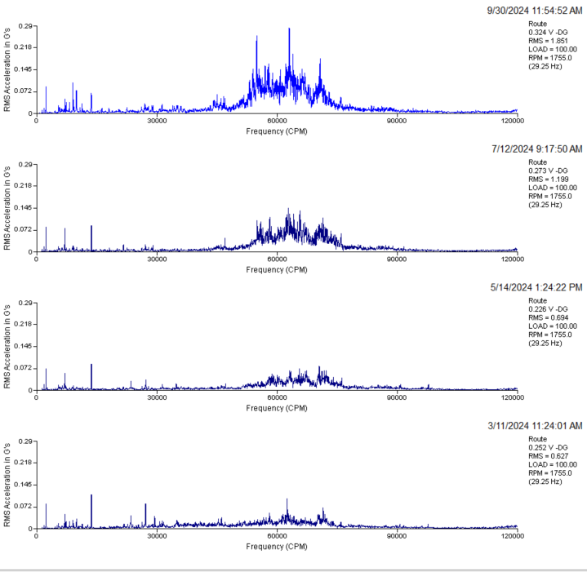
#1 I.D. Fan –Motor Bearing Defect - Class II Defect
The #1 I.D. Fan, drive side bearing, shows signs of impacting in the waveform (bottom) indicative of minor looseness. The spectrum shows at least two separate non-synchronous harmonics indicative of bearing faults. Monitor this motor for increased noise and vibration.

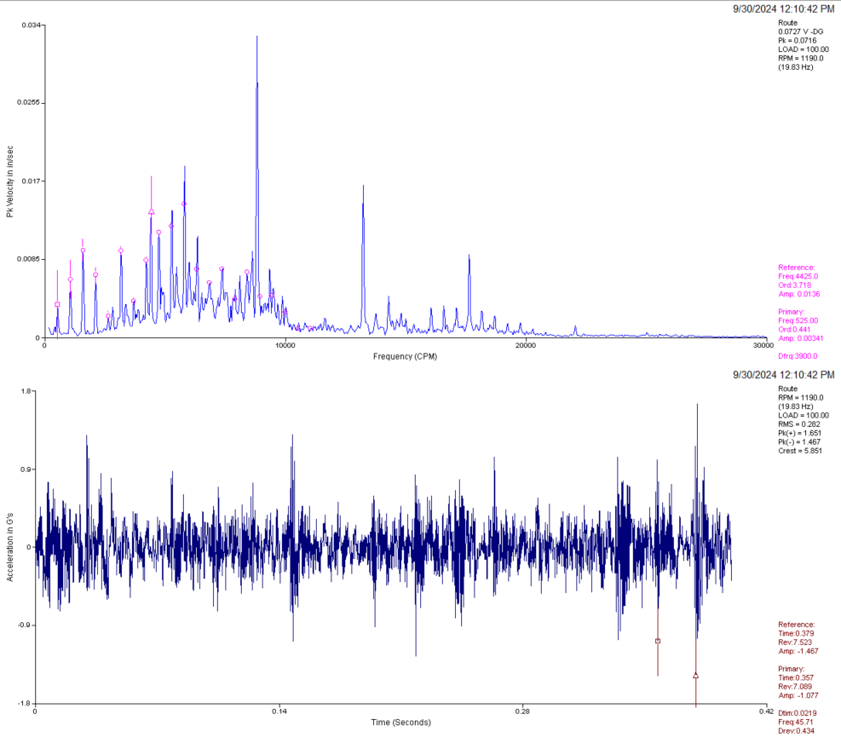
High Freq. harmonic
Low Freq. harmonic
#3 Primary Fan – Fan Unbalance - Class I Defect
The #3 Primary Fan shows an increase in running speed vibration. Clean the fan of accumulation and inspect for erosion or thrown balance weights.
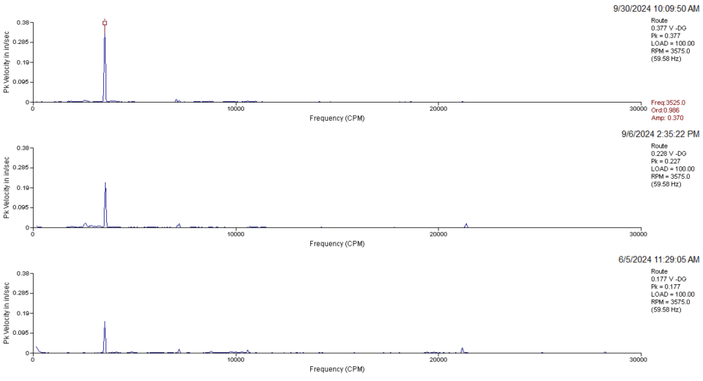
Calcine #9 Dust Collector Fan – Fan Bearing Class IV Defect
No new data was collected on this unit on 9/30/24.
The #9 Dust Collector Fan, outboard fan bearing, showed significant signs of impacting in the waveform in February and March ’24. Non-synchronous vibration increased significantly in the following months. The waveform is off center, indicating looseness and rubbing. Replace this bearing as soon as possible.
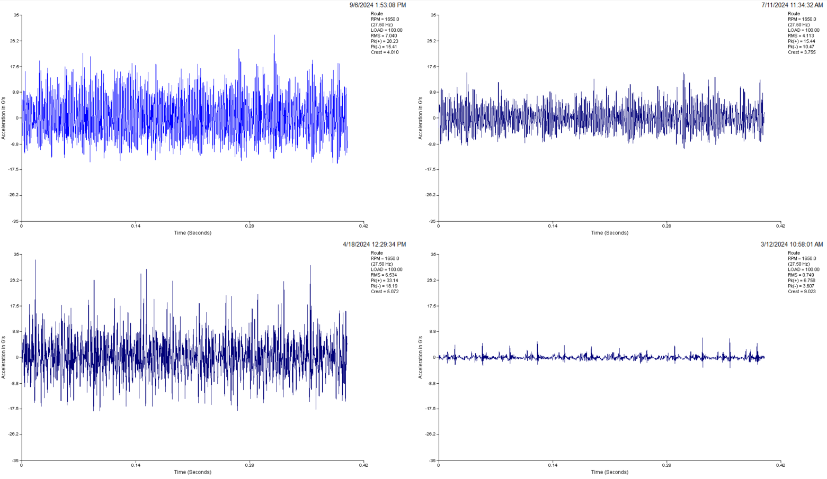
Calcine #11 Dust Collector Fan – Fan Bearing Class III Defect
The #11 Dust Collector Fan, outboard fan bearing, shows a sudden rise in vibration between 7-24 and 9-24. Peak waveform energy is high (right) and high frequency “haystacking” as well as distinct, mid frequency non-synchronous peaks on the spectrum (left) are present. This is indicative of bearing wear or damage. Plan to replace this bearing soon.
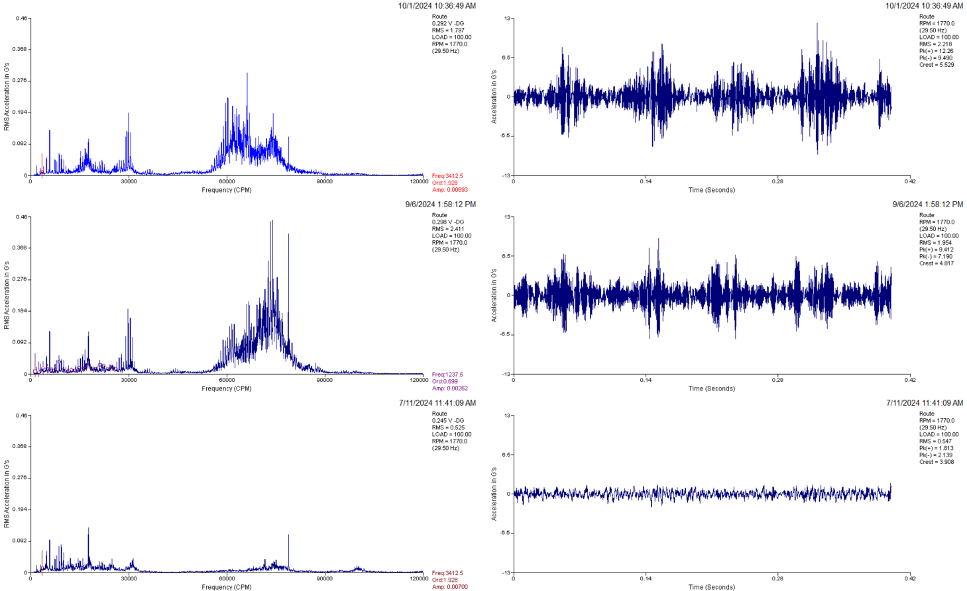
Building 55 Flex Kleen Fan – Outboard Bearing Class III Defect
The Building 55 Flex Kleen Fan, fan non-drive end bearing showed significant improvement between March and May ’24 but much lower amplitude impacting was still evident in the waveform in May, July, and September. In September a higher frequency indistinct “haystack” appeared, (left) and overall waveform energy increased (right) indicating the rolling element faults may be spreading. The fault indications continue to increase as of 10/1/2024. Lubricate this bearing. Check shaft to bearing fit. Check for bearing looseness. Monitor for increased temperature and noise. Have a plan to replace this bearing. Ensure proper installation procedures to avoid damaging the bearing. The bearing may have been damaged during installation or it may have had a defect out of the box.
