|  |  |  |  |
| --- | --- | --- | --- |
| **Customer:** | Southern Cotton Oil | **Location/Desc:** | Memphis |
| **Address:** | 2782 Chelsea | **Performed by:** | Joseph Schurtz |
|  | Memphis ,TN 38108 | **Date:** | 06/16/2023 |
| **Job/Order#** | 150456 |  |  |

|  |  |  |  |
| --- | --- | --- | --- |
| **Reason for call:** | Describe services performed. | | |
| **Description of work:** | Align motor | | |
| **Equipment and material used:** | 12 B shims used | | |
| **Recommended additional work:** |  | | |

|  |  |  |  |
| --- | --- | --- | --- |
| **Main Contact:** | Peter Howell | | |
| **Customer Signature:** |  | | |

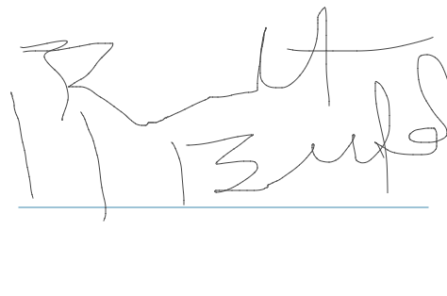

**2023-09-21 14:23:41**  
We are reviewing the Issue with "jobs not closing after billing" (JTW) **2023-08-07 09:17:03**  
Billing 8/7(JMM)