|  |  |  |  |
| --- | --- | --- | --- |
| **Customer:** | Quikrete-Memphis | **Location/Desc:** | Memphis |
| **Address:** | 4362 Millington Road | **Performed by:** | Kevin W Maxwell |
|  | Memphis ,TN 38127 | **Date:** | 05/31/2023 |
| **Job/Order#** | 150316 |  |  |

|  |  |  |  |
| --- | --- | --- | --- |
| **Reason for call:** | Balance check on dust collector | | |
| **Description of work:** | Performed balance check on fan after base repairs.  Found fan to be in balance and all weights still in place. No issues to note. | | |
| **Equipment and material used:** |  | | |
| **Recommended additional work:** |  | | |

|  |  |  |  |
| --- | --- | --- | --- |
| **Main Contact:** | Malcom Smith | | |
| **Customer Signature:** |  | | |

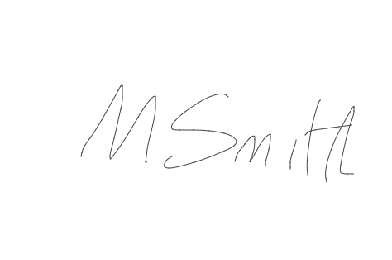

**2023-06-14 14:53:26**  
Requesting PO from Customer for Billing (JMM)