WEEKLY OPEN ORDERS MEETING

CRM
REPORTS
WAREHOUSE SCORECARD
ML: ORDERS PAST PROMISE DATE

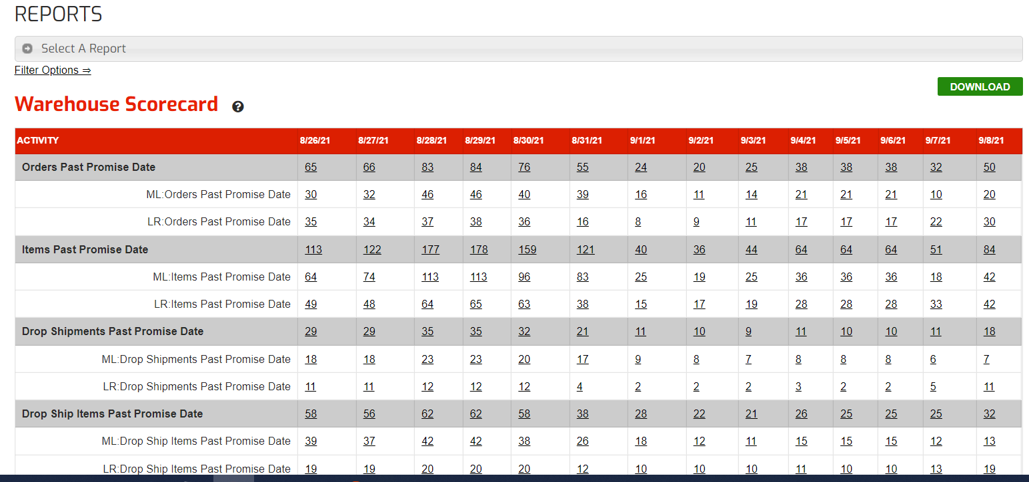

GO THROUGH EACH ORDER AND PROVIDE UPDATE TO SALES TEAM

