Process for cycle counting
- Make sure invoicing is caught up
- Open up the cycle count spreadsheet to determine which cycle code is due to be counted.
- The choice is done at random depending on the amount of time I have to count.
- Run the inventory for the chosen cycle code and complete the process.
- Update the cycle count spreadsheet.
- Absolutely nothing needs to be done in ACS while there is a cycle count open.
- Once the register is ran the process is complete and normal business activity in ACS can continue.
- Criteria are as follows: Harington to be counted 2 times a year while everything else is to be counted once per year.

DO NOT PERFORM CYCLE COUNTS UNTIL ALL EOD DAILY SHIPMENTS ARE COMPLETED AND SALES REGISTER UPDATED ALONG WITH RECEIVING AND TRANSFER REGISTERS UPDATED

CYCLE COUNT CRITERIA: HARRINGTON ITEMS ARE COUNTED TWICE A YEAR WHILE ALL OTHER ITEMS ARE COUNTED ONCE A YEAR
COUNTS ARE PERFROMED 1 ROW A MONTH WHICH CONSISTS OF APPROX 1 SHELF PER WEEK BEGINNING WITH HARRINGTON PRODUCTS LOCATED IN ROWS 3, 4 , 5 & 6 AND ENDCAPS 1, 2 & 3
LOCATE THE CYCLE COUNT WORKSHEET IN LOCATION: S/JEREMY/CYCLECOUNTS TO DETERMINE THE APPROPRIATE NEXT CODE
RUN THE PHYSICAL INVENTORY SELECTION:
DISTRIBUTION/INVENTORY/PHYSICAL INVENTORY/PHYSICALINVENTORYSELECTION
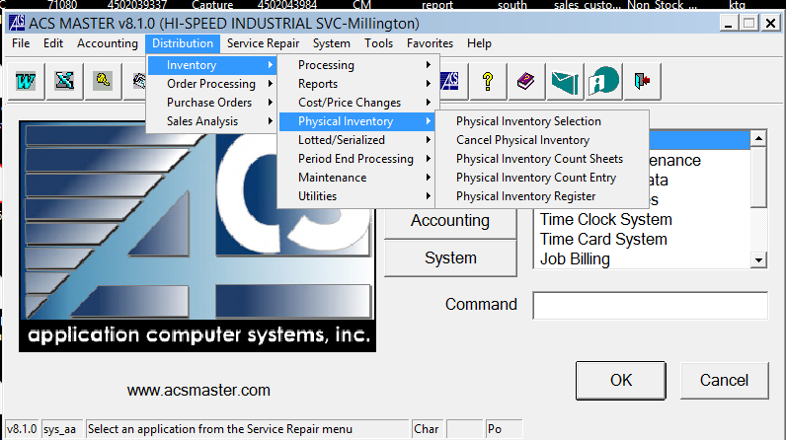
CONFIRM ALL REGISTERS ARE UPDATED AS STATED ABOVE AND CLICK OK
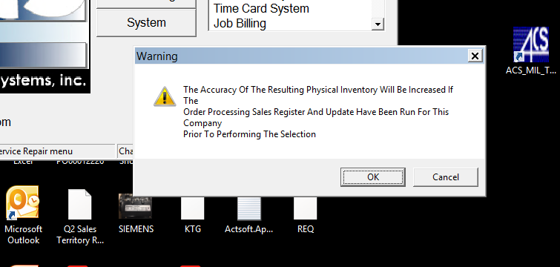
CONFIRM WAREHOUSE 01 FOR CYCLE COUNTS AND CLICK OK
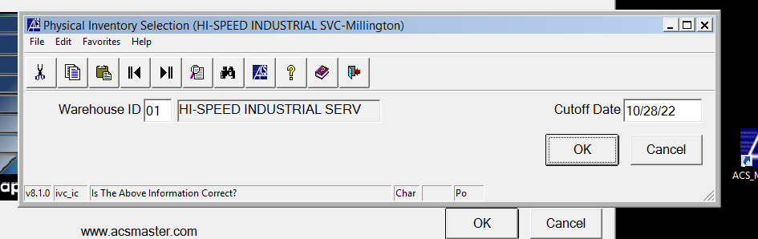

ENTER THE CYCLE CODE TO PERFORM YOUR COUNT AND CLICK OK TWICE
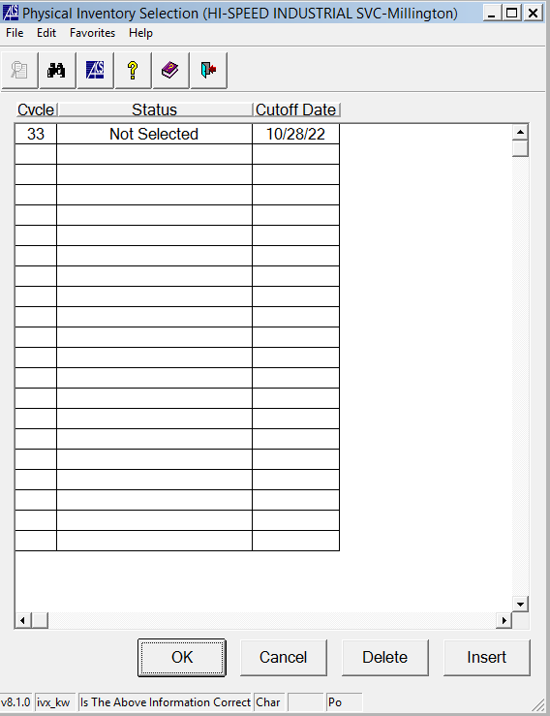

PRINT CYCLE COUNT SHEETS
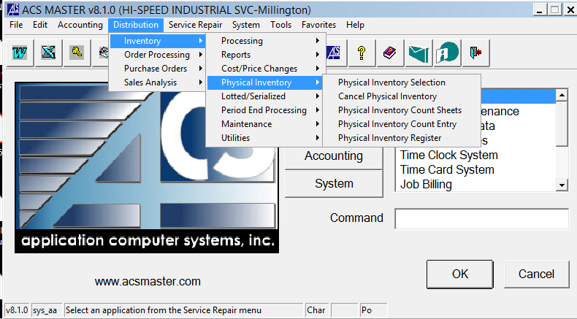
CHECK THE BOX TO PRINT QUANTITIES ON THE COUNT SHEET IF NEEDED.
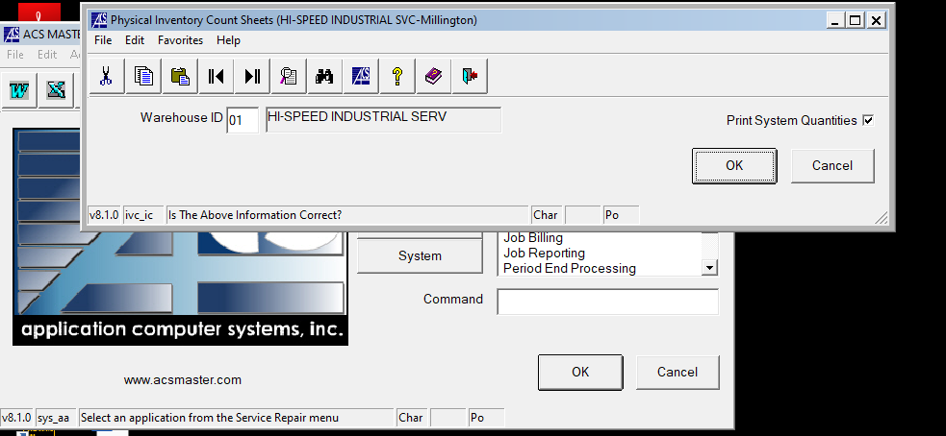

KEY IN CYCLE CODE
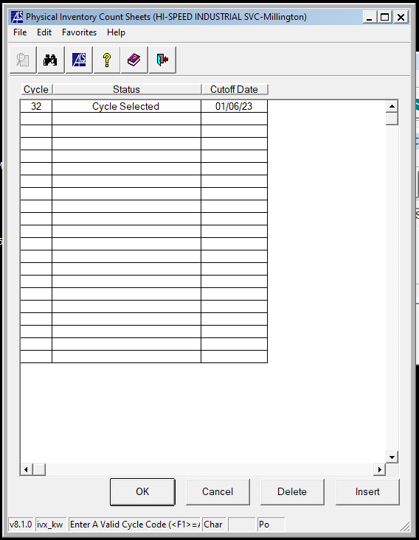

CHECK THE PDF BOX AND HIT EXECUTE
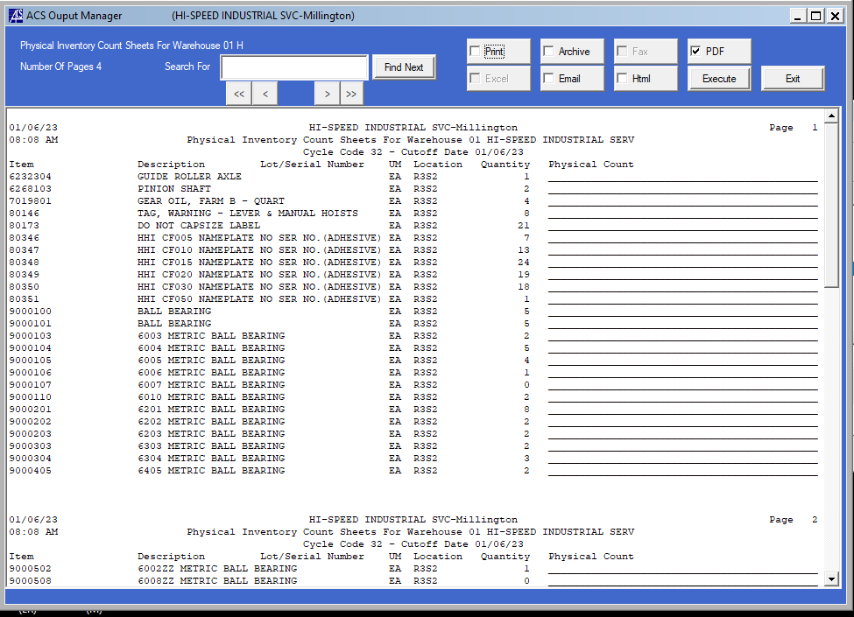
PRINT YOUR COUNT SHEETS
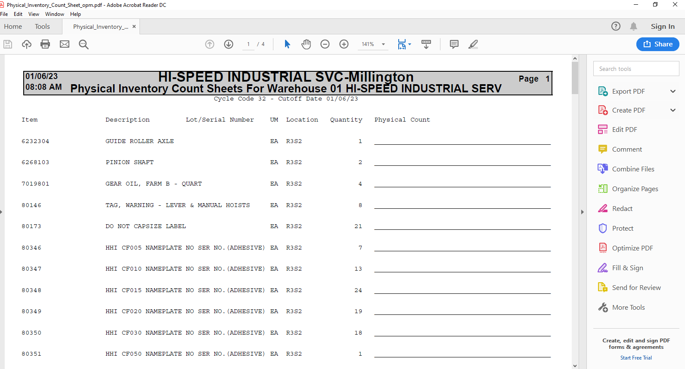

KEY THE RESULTS OF YOUR COUNT
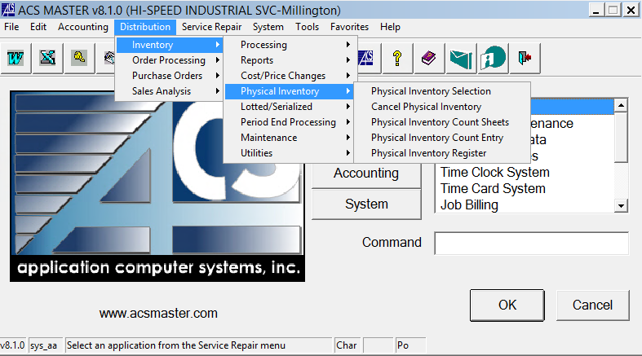
WAREHOUSE 01 WILL POPULATE
ENTER CYCLE CODE
CUTOFF DATE WILL POPULATE
ITEM NUMBER WILL POPULATE WHEN OK IS CLICKED OR ENTER BUTTON PRESSED
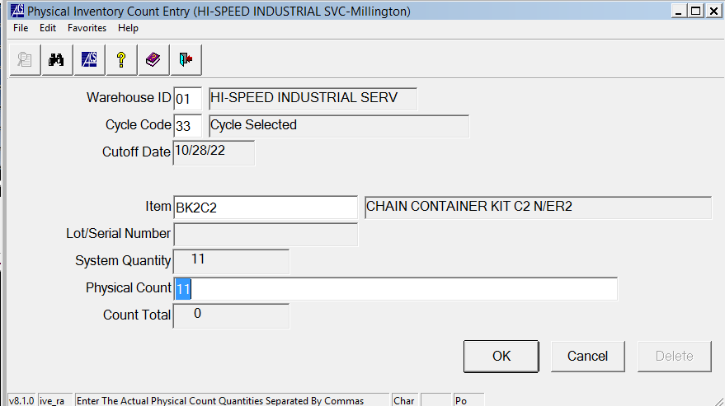
KEY YOUR PHYSICAL COUNT
COMPLETE PROCESS FOR ALL ITEMS
CANCEL OUT OF SCREEN ONCE ALL ITEMS ARE KEYED
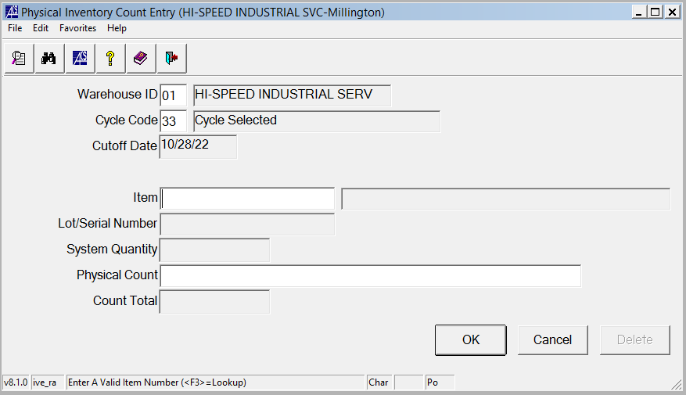
RUN PHYSICAL INVENTORY REGISTER

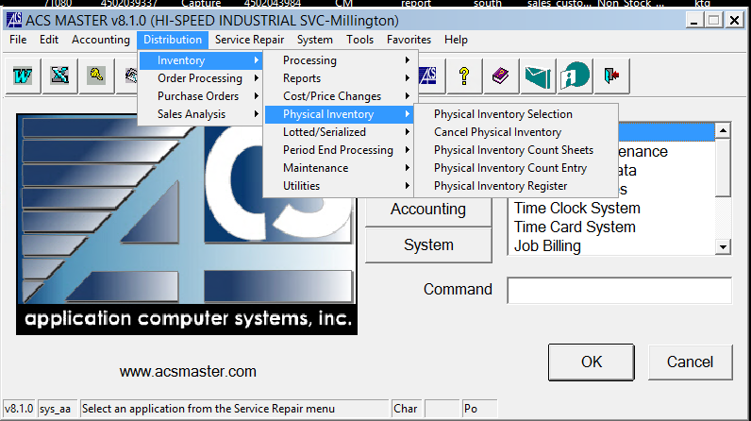

CLICK OK
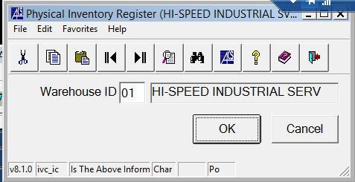

ENTER SAME CYCLE CODE
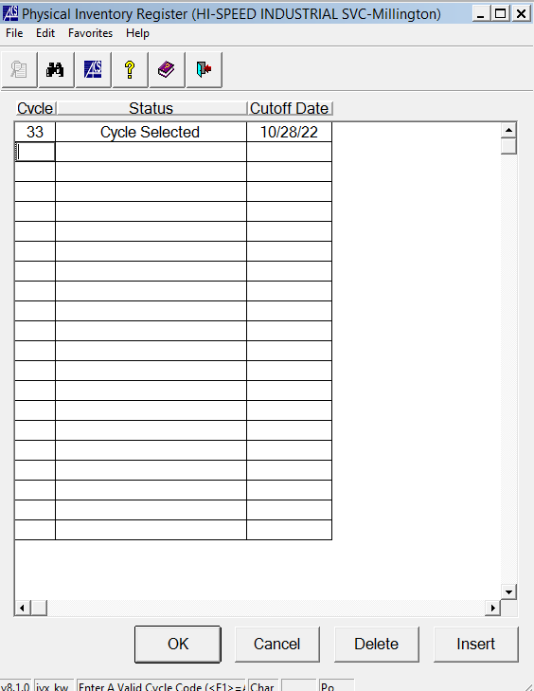

CLICK OK TWICE
GENERATE THE PDF BY CLICKING PDF AND EXECUTE
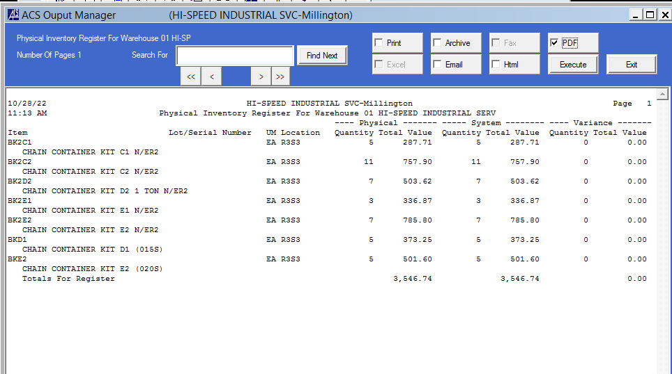

SAVE THE REGISTER IN THE CYCLE COUNT FOLDER LOCATED S/JEREMY/CYCLECOUNTS
REGISTERS ARE SAVED AS THE CYCLE COUNT NUMBER

CLICK YES TO UPDATE THE REGISTER
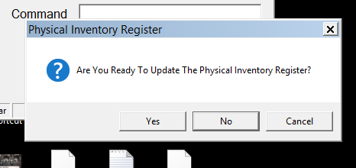

Add audit section and person to this process

