DAILY OPERATIONS - OPEN ORDERS REPORT

CRM

REPORTS

“OPEN ORDERS FULL REPORT DOWNLOAD”



GENERATE EXCEL FOR DOWNLOAD

OPEN THE REPORT BY CLICKING ON THE REPORT

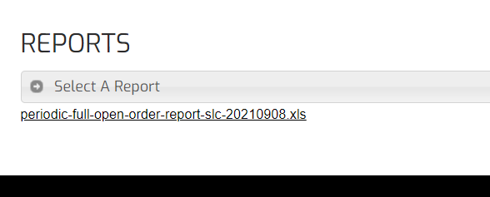



SAVE THIS REPORT IN DAILY SCORECARD FOLDER USING PATH BELOW:

S:\INVENTORYANALYSIS\DAILYSCORECARD

OPEN PREVIOUS SAVED REPORT

RIGHT CLICK BOTTOM TAB

MOVE OR COPY (MOVE TO YOUR NEW REPORT)

MOVE TO END

CREATE A COPY



THIS HAS CREATED A COPY OF THE OLD SHEET IN YOUR NEW NOTEBOOK

WHILE VIEWING THE NEW SHEET

VIEW THE MACRO



\*\*THE MACRO MUST BE UPLOADED ON YOUR PERSONAL COMPUTER – SEE VIDEO IN THE FOLLOWING LOCATION TO CORRECTLY UPLOAD THE MACRO ON YOUR PERSONAL COMPUTER: S:\INVENTORYANALYSIS\TRAININGVIDEOS&DOCUMENTS/ADDINGAMACROTOANEWCOMPUTER\*\*

RUN THE MACRO

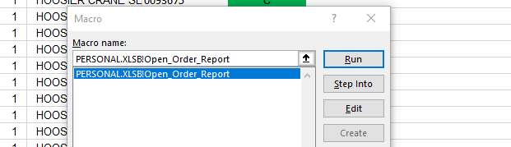



THIS COMBINES DATA FOR BOTH DAYS AND DELETES THE EXTRA SHEET

BEGIN BY IDENTIFYING ALL DROP SHIPS THAT WERE ENTERED FROM THE PREVIOUS WORKDAY

COLUMN “U” = “Y” TO IDENTIFY ALL DROP SHIPS

THE SPREADSHEET IS READY TO USE

SAVE AND UPDATE THROUGOUT DAY WITH COMMENTS

ORDERS PULLED AND SHIPPED ARE MARKED COMPLETE ON THIS SPREADSHEET IMMEDIATELY FOLLOWING THE DAILY PICKUP

EVERY PAST DUE ORDER IS IDENTIFIED AND UPDATED WITH COMMENTS: WAITING ON VENDOR INVOICE, NEW VENDOR SHIP DATE, ETC.