Material Charge-Out Procedure

ISO Section: 7.4

- Purpose
Accurately capture, report & monitor material charge-outs for repair jobs
- Scope
This procedure applies to all motor & hoist repair used at Hi-Speed.
- Definitions and Acronyms
LVM (Low Value Motor): Defined as low value materials utilized in the repair or modification of products processed by Hi-Speed Motor Repair. Low Value material items include, but are not limited to, adhesives, brazing materials, fasteners, gases, gasket materials, grinding discs, insulation, insulation paint, insulation tapes, lead cable, lead labels, lugs, lubricants, mica tapes, sleeving, tie-down cord, zip ties, etc. utilized in the repair of products processed by Hi-Speed Motor Repair. Low Value items are calculated as 5% of total labor costs.

LVH (Low Value Hoist): Defined as low value materials utilized in the repair of hoist products processed by Hi-Speed Hoist Repair. Low Value material items include, but are not limited to, adhesives, brazing materials, fasteners, gases, gasket materials, grinding discs, insulation, insulation paint, insulation tapes, lead cable, lead labels, lugs, lubricants, mica tapes, sleeving, tie-down cord, zip ties, etc. utilized in the repair of products processed by Hi-Speed Hoist Repair. Low Value items are calculated as 5% of total labor costs.

RIN (Rewind Insulation): Defined as total pounds of wire products utilized in the rewind of components processed by Hi-Speed Motor Repair. RIN is calculated as follows: Total Pounds of Wire Used x $1.00 per pound with no maximum limit.

RESIN (XL2103): Defined as Von Roll Dolphon XL-22103, a multipurpose Class H polyester based epoxy resin.

VPI (74041) Defined as Von Roll Permafil 74041, a multipurpose high build, UL Rated, Class H polyester based epoxy resin.

- Responsibilities

Shop Coordinator & Dept. Manager are responsible for ensuring this procedure is implemented.

- Procedure
  - Verification of Purchased Products

    - Purchases are charge to the following G/L accounts:
      - LH – Low Value Hoist – 1305-00
      - LV – Low Value Motor – 1412-00
      - RI – Rewinding Material – 1304-00
    - Upon receipt, part numbers and quantities are verified to the packing slip and packages are inspected for visible damage.
    - Product received from Supplier are inspected, and documented when necessary or needed.
  - Adding Material Charges
    - Access ACS
    - Go to Material Charges under service repair
    - Go to Material Charge Entry
    - Enter Job #
    - Enter Warehouse#
      - Millington – 01
      - Little Rock – 02
      - Millington Consignment – Z1
      - Little Rock Consignment – Z2
    - Type in Item # If Stock
      - If Stock
      - If not Stock then F3 and enter the 2 to 4 digit code for the G/L category:
        - LVH – Low Value Hoist – 1305-00
        - LVM – Low Value Motor – 1412-00
        - RIN – Rewinding Material – 1304-00
        - FRHR – Freight Hoist
        - FRMR – Freight Motor
        - And other codes for Mileage (MHR/MMR), Equipment Rental (EQHR/EQMR), Small Tools, Office Supplies, Etc.
        - Then Type in the Description if not already populated correctly.
    - Calculate
      - Low Value items (5% of total labor costs)
      - RIN (Total Pounds of Wire Used x $1 per pound)
      - Resin XL2103 amount using chart 1 or HP x 0.0463
      - Calculate VPI 74041 amount using chart 1 or HP x 0.0463
    - Enter Quantity
    - Enter unit of Measure
    - Enter Unit Cost
    - Press Ok

- Reference Documents
Resin Allocation Per Motor
 |  | XL2103 | 74041
HP | Multiplier | Resin Gallons | Resin Gallons
0.25 | 0.0463 | 0.011575 | 0.011575
0.5 | 0.0463 | 0.02315 | 0.02315
0.75 | 0.0463 | 0.034725 | 0.034725
1 | 0.0463 | 0.0463 | 0.0463
1.5 | 0.0463 | 0.06945 | 0.06945
2 | 0.0463 | 0.0926 | 0.0926
3 | 0.0463 | 0.1389 | 0.1389
5 | 0.0463 | 0.2315 | 0.2315
7.5 | 0.0463 | 0.34725 | 0.34725
10 | 0.0463 | 0.463 | 0.463
15 | 0.0463 | 0.6945 | 0.6945
20 | 0.0463 | 0.926 | 0.926
25 | 0.0463 | 1.1575 | 1.1575
30 | 0.0463 | 1.389 | 1.389
40 | 0.0463 | 1.852 | 1.852
50 | 0.0463 | 2.315 | 2.315
60 | 0.0463 | 2.778 | 2.778
75 | 0.0463 | 3.4725 | 3.4725
100 | 0.0463 | 4.63 | 4.63
125 | 0.0463 | 5.7875 | 5.7875
150 | 0.0463 | 6.945 | 6.945
250 | 0.0463 | 11.575 | 11.575
300 | 0.0463 | 13.89 | 13.89
350 | 0.0463 | 16.205 | 16.205
400 | 0.0463 | 18.52 | 18.52
450 | 0.0463 | 20.835 | 20.835
500 | 0.0463 | 23.15 | 23.15
600 | 0.0463 | 27.78 | 27.78
700 | 0.0463 | 32.41 | 32.41
800 | 0.0463 | 37.04 | 37.04
900 | 0.0463 | 41.67 | 41.67
100 | 0.0463 | 4.63 | 4.63
1250 | 0.0463 | 57.875 | 57.875
1500 | 0.0463 | 69.45 | 69.45

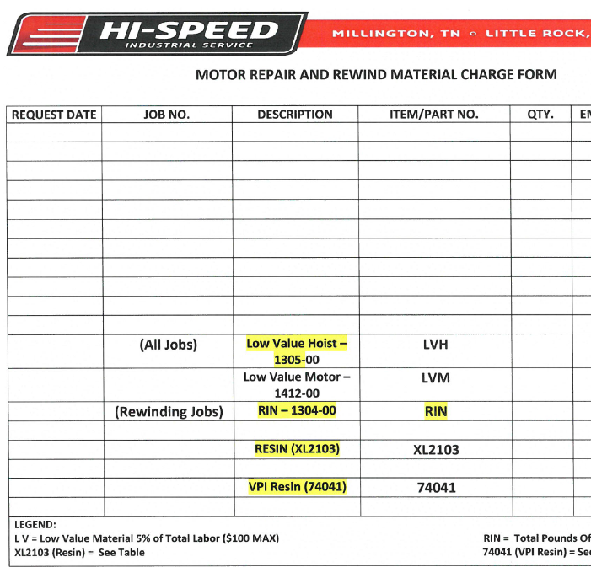
- Change Log
Document Revision Date | Description of Change
08/28/2017  10/19/2017  12/21/2017 | Initial Release  R1  R1.1

