HOW TO TRANSFER PRODUCT FROM ML TO LR

1. Select Distribution, Inventory, Processing, Inventory Transaction Entry

1. Reference # use the date
2. Transaction Code use TF
3. Comment use TRSF TO LR (- ENTRY)

1. Type warehouse product is coming from
2. Type item #
3. Type quantity and if taking away inventory use negative then quantity. Ie -4

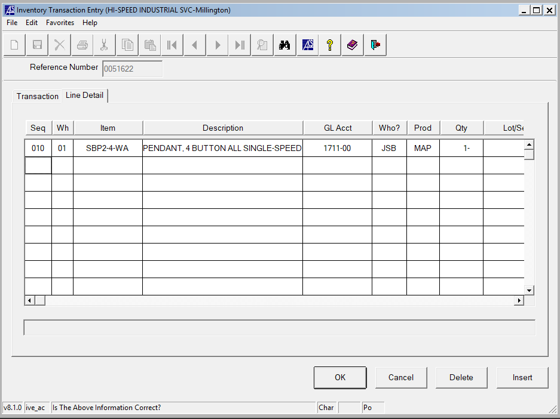

1. Hit OK
2. Hit Distribution, Inventory, Processing, Inventory Transaction Register

1. Hit YES
2. Check PDF box and hit Execute

1. Save file under the folder Inventory Transactions S:\_2022 ACS Printouts\Inventory Transactions
2. Hit YES to update the register.

1. Send Tina Thompson an email with the register attached so when LR adds to their inventory the prices will match.