HOW TO RECEIVE A PURCHASE ORDER

- Select Distribution
- Select Purchase Order

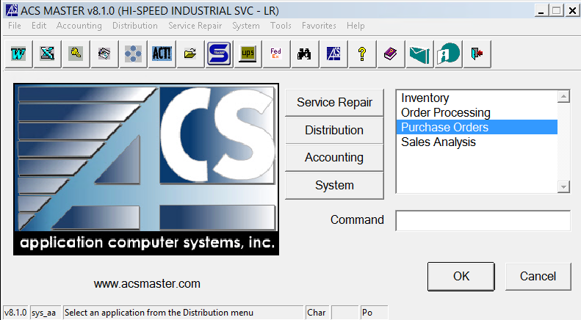

- Select Purchase Order Receipt Entry

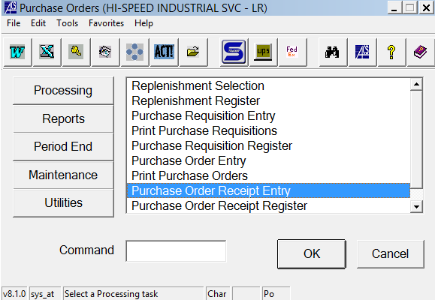

- Hit F2 and enter the PO number. Enter. This will bring your vendor info in as well.
- Hit F1 to get your Receiver #. Write that number on your PO. Hit enter.
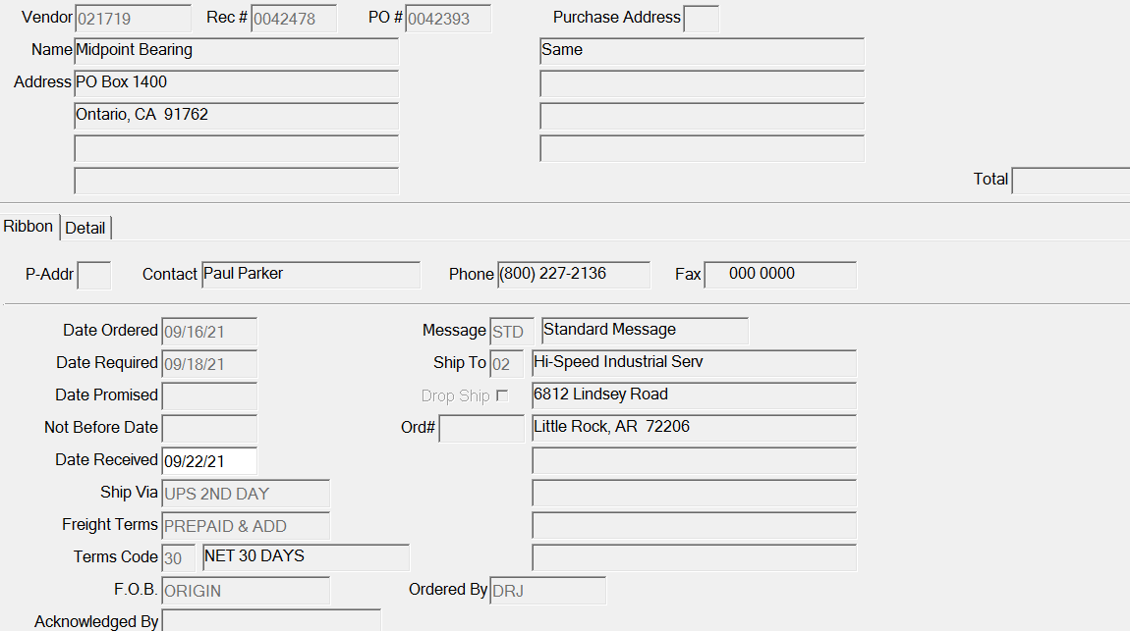
- Click OK. If you are completely receiving the PO in (did everything, come in on the PO?).

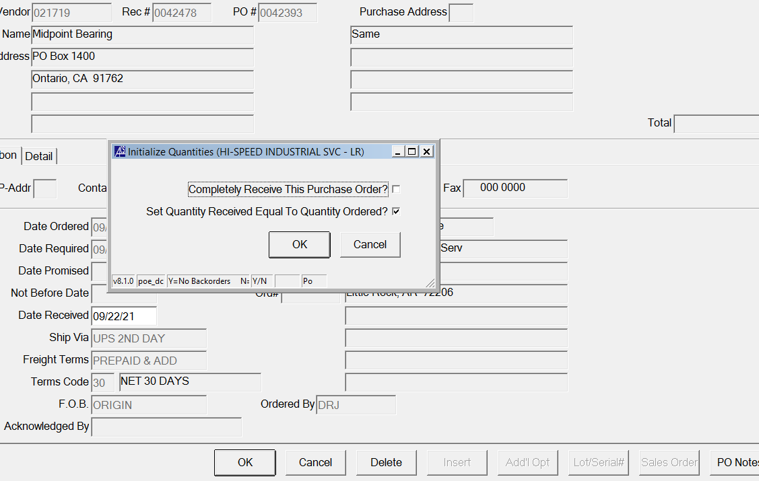

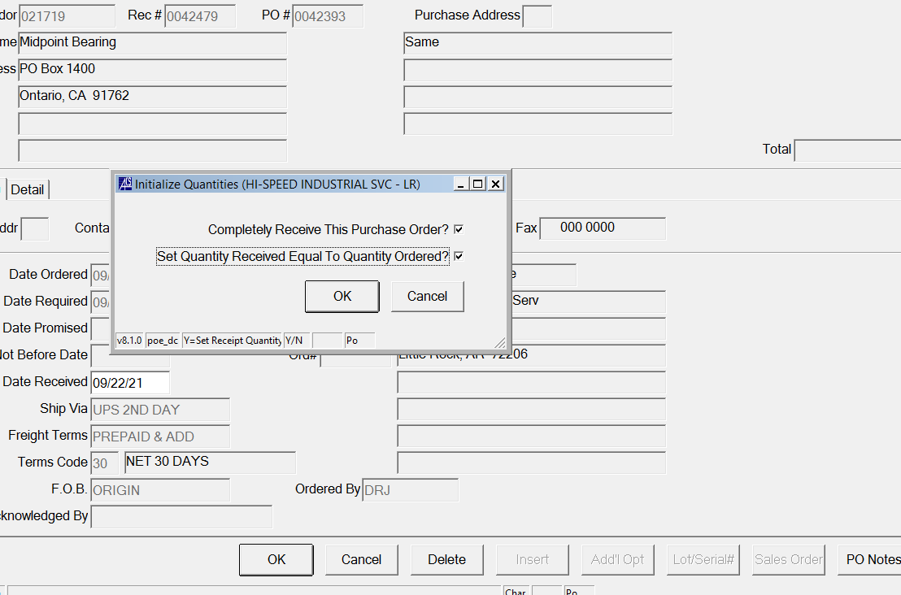

- Click this box if everything came in on the PO

- Uncheck this box if everything did not come in on the PO; this would be partial receiving the PO

- Enter the quantities you want to receive in for the partial receiving.

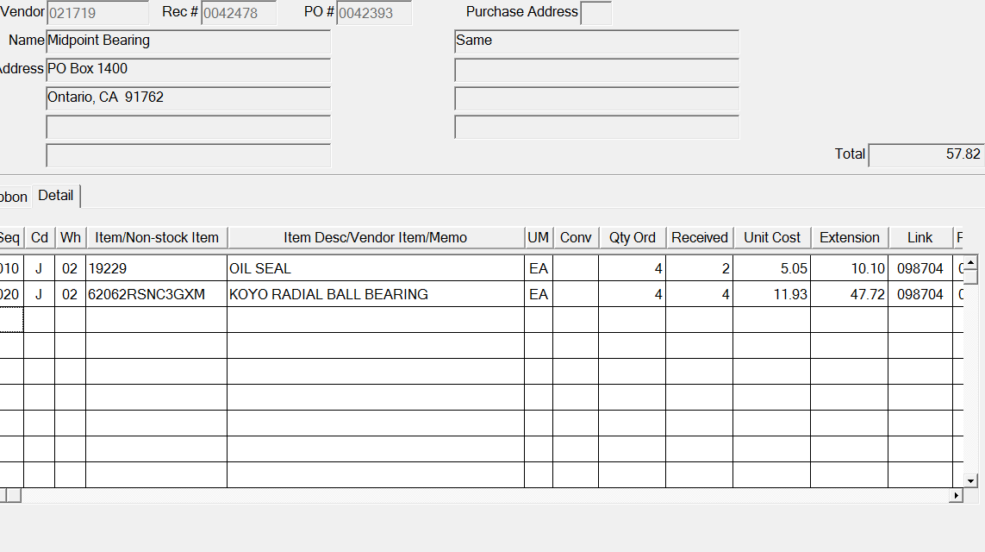

- Click OK.
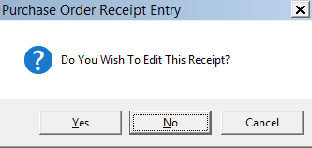

- Click No.

