PO Tracking Instructions
“JOBS”

- Go to S: Procedures/Purchase Order Tracking/Purchase Order Tracking.xlsc and open spreadsheet
- Go to “PO” Folder in email account, looking daily at recent POs
- Reviewing the POs in the folder, determine if they are ML or LR and if they are Job or Service/Order
- Fill in any data, into the spreadsheet, that can be collected from the PO in the PO folder
If it is for ML Job, open ACS ML. If it is for LR job, open ACS LR:
PO TRACKING JOB
PO Received Date in ACS Instructions
Go into the appropriate ACS - >Click on Speed Search
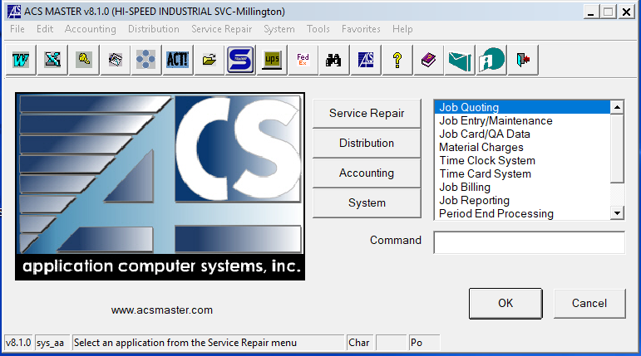
Select, F3; Go to Service Repair - >Job Inquiry, following screen will open
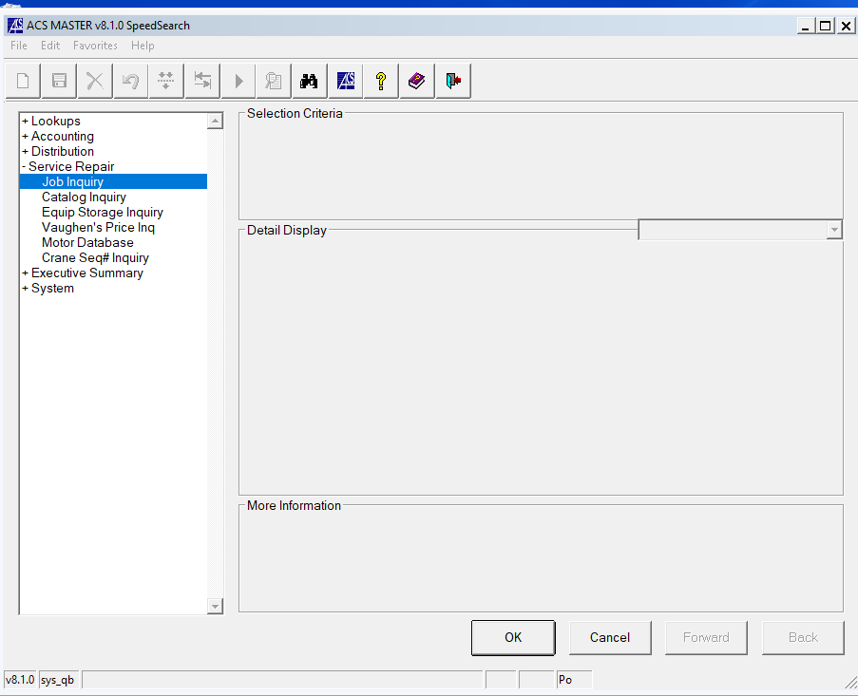
Select Job Inquiry, following screen will open up; Click “Active”

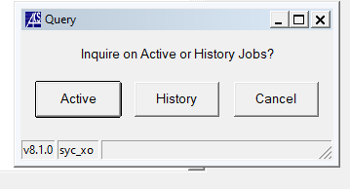
Then select “F3”

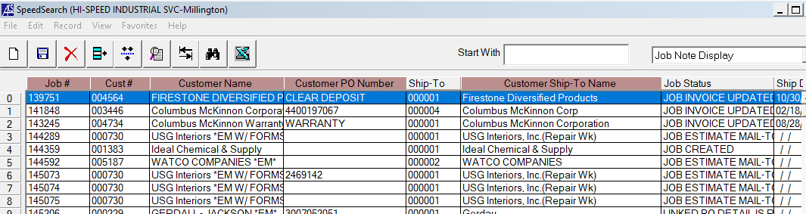

Type in PO number rom spreadsheet and click on the “Customer PO Number Column”
If you do NOT see the PO number, go to the next number
If you DO see the PO number, fund the “Receipt Date” column and enter it into Column M “Rec’d in ACS” in the spreadsheet.
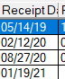
Once you have finished looking at all active orders, Press Cancel and F1
Click “History”
Select “F3”

Type in each PO number from the spreadsheet and click on the “Customer PO Number Column”

If you do NOT see the PO number, go the next number
If you DO see the PO number, find the “Receipt Date” column and enter it into Column M “Rec’d in ACS” in the spreadsheet.
Type in the Customer # (if you do not know it, need to look up customer # first before using this instruction—see instructions below on how to look up customer number)
HOW TO LOOK UP CUSTOMER NUMBER:
1-Using filter on column F, look to see if it has been previously recorded, then copy & paste into the new cell
2-If not been previously recorded, need to look up in ACS
Select Binoculars, then select “F3”
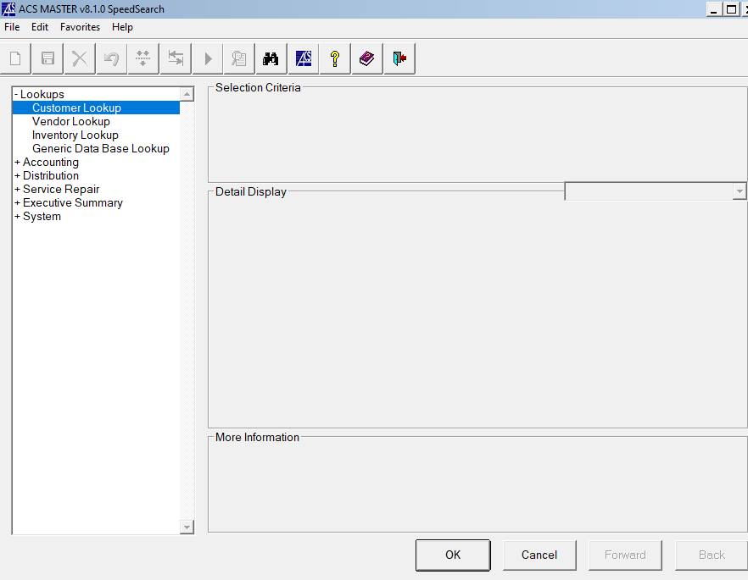
Select “Customer Lookup”
Type in Customer Name in column “Start With”
Click on Column “Name”
Look at first column “Customer Number”. Copy and paste this number into PO tracking spreadsheet Column F.
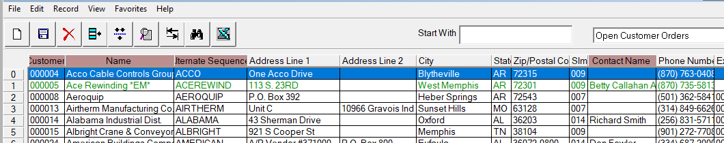
PO Tracking Instructions
“SERVICE/ORDER”

- Go to S: Procedures/Purchase Order Tracking/Purchase Order Tracking.xlsc and open spreadsheet
- Go to “PO” Folder in email account, looking daily at recent POs
- Reviewing the POs in the folder, determine if they are ML or LR and if they are Job or Service/Order
- Fill in any data, into the spreadsheet, that can be collected from the PO in the PO folder

If it is for ML Service/Order, open ACS ML. If it is for LR Service/Order, open ACS LR:
PO TRACKING SERVICE/ORDER
PO Received Date in ACS Instructions
Go into the appropriate ACS - >Click on Speed Search
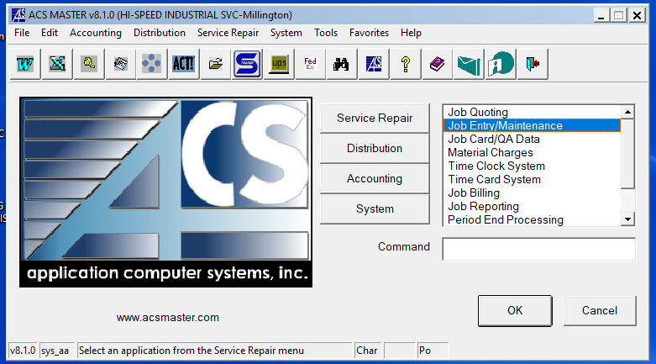

Select “Distribution” -> Select Invoice History
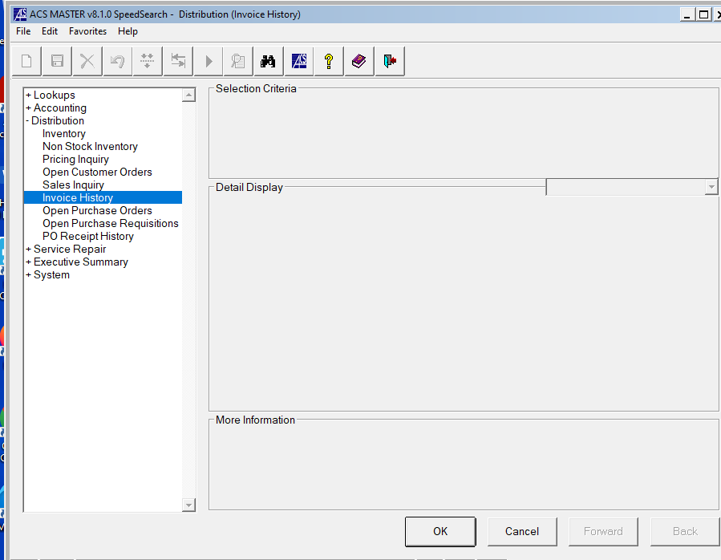

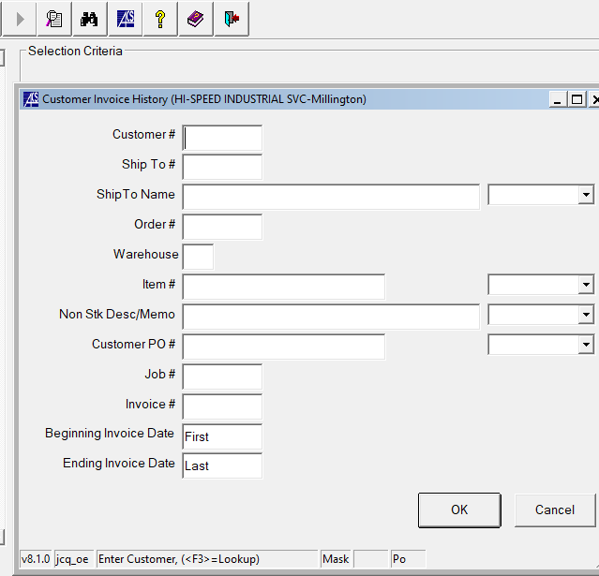

Depending on the information you have, enter the “Customer #”, “Order #” and/or Customer PO#”
Press “OK”
Enter in the “Ord Date” as the “Rec’d in ACS” date (into PO Tracking spreadsheet)
If you DO NOT get any results, go to the next step
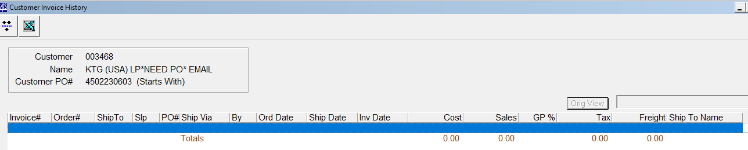
Distribution -> Open Customer Orders
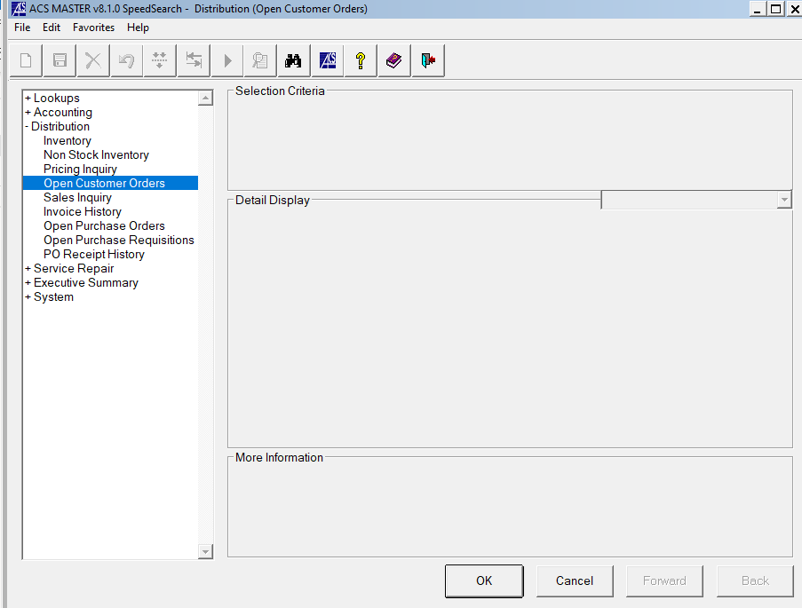

Type in the Customer # (if you do not know it, need to look up customer # first before using this instruction—see instructions on next page on how to look up customer number)
Press “Ok”
Look for the order(s) on your spreadsheet for that customer
Enter in the “Ord Date” as the “rec’d in ACS” date (into PO Tracking spreadsheet
*Sometimes, the PO# might not match the spreadsheet. You will also need to loof for the “Order Cost” amount to try to match them up.”

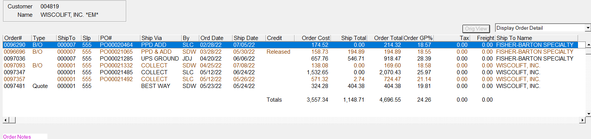

HOW TO LOOK UP CUSTOMER NUMBER:
1-Using filter on column F, look to see if it has been previously recorded, then copy & paste into the new cell
2-If not been previously recorded, need to look up in ACS
Select Binoculars, then select “F3”
Select “Customer Lookup”
Type in Customer Name in column “Start With”
Click on Column “Name”
Look at first column “Customer Number”. Copy and paste this number into PO tracking spreadsheet Column F.

